**2016 Rover Battery System**

**Mars Rover Design Team**

**Student Design and Experiential Learning Center**

**Missouri University of Science and Technology**

**Josh Jetter**

**July 10, 2015**

**Revision History**

**Table of Contents**

List of Figures

List of Tables

Introduction

Battery Pack

Battery Cells

Cell Modules

Battery Management System

Requirements

System Architecture

Monitoring Analog Front-End

Microcontroller

Pack Load Switch

Cooling Fans

Indicators

Serial Data Interface

System Power Supply

Software

Battery Charger

Charging Requirements

Buck-Converter Design

High-Level Converter Design

Inductor Selection

MOSFET Switch Selection

MOSFET Driver Selection

Diode Selection

Filtering Capacitor Selection

Total Losses

Monitoring and Control Hardware

Acknowledgments

References

Appendices

Appendix A: Inductor Calculations Octave Source Code

Appendix B: SPICE Component Models

Appendix C: Bill of Materials

**List of Figures**

**List of Tables**

**Introduction**

The battery system for the 2016 rover encompasses everything necessary for the battery pack’s operation, which includes the battery management system, the battery charger, and the battery cells themselves.

**Battery Pack**

**Battery Management System**

A core component of the rover’s battery pack is the Battery Management System (BMS) which is responsible ensuring the battery operates efficiently and within a safe operating area (SOA) defined by voltage, current, temperature.

**Requirements**

The BMS’s functional requirements are split into two categories: protection and management [21]. The protection portion of the BMS is responsible for preventing cell under- and over-voltage conditions, preventing pack over-current conditions, and keeping the battery pack within its temperature limits. These characteristics describe the battery pack’s safe operating area. Table 1 describe the safe operating area characteristics for both individual cells and the entire pack, as well as how the BMS can react to maintain these conditions. The battery pack limits are based on the eight series modules with ten parallel cells as described in the *Battery Pack* section of this document.

|  |  |  |  |
| --- | --- | --- | --- |
| **Property** | **Cell Limit** | **Pack Limit** | **BMS Actions** |
| Under-voltage | 2.5V | 20V | Disconnect load; charge pack |
| Over-voltage | 4.2V | 33.6V | Disconnect charger; balance cells |
| Over-current | 20A (continuous) | 200A (continuous) | Request reduction of load; disconnect load |
| Under-temperature | 0°C (charging)  -20°C (discharging) | | Heat battery pack (power balancing resistors) |
| Over-temperature | 50°C (charging)  75°C (discharging) | | Cool battery pack (turn fans on) |

**Table 1 –** Summary of BMS Safe Operating Area Characteristics [20].

When performing the monitoring functions, it is also critical that the BMS considers the importance of transient conditions versus continuous conditions, i.e. it is often acceptable to operate outside of the SOA for brief period of time. For example, the BMS will need to consider the fact that the cells have a higher pulse discharge rating that continuous discharge rating. It would be undesirable for the pack to stop powering the load due to something as harmless as load transient conditions.

In order to achieve the battery protection functional requirements, the BMS must have hardware that is capable of making the SOA characteristic measurements and hardware that can take action to act on this data. The measurement functionality is the responsibility of the BMS’s analog front-end. The ability to disconnect the battery from a load is the responsibility of the BMS’s pack on-off switch. Preventing under- and over-voltage conditions is the responsibility of the pack’s charger hardware, balancing hardware, and the on-off switch. Finally, preventing over-temperature conditions is the responsibility of the pack’s cooling fans controlled by the BMS.

Additional functional requirements for the BMS are considered “battery management” functionalities [21]. This includes state of charge (SoC) estimation, state of health (SoH) estimation, passive cell balancing, emergency stop button support, external reporting of telemetry data, visual SoC indication, and visual telemetry indication.

State of Charge estimation describes the ability of the BMS to determine how much usable charge remains in both cell modules and the entire pack. Since cell open-circuit voltage is not linearly related to cell SoC (see figure 1), it cannot be the sole source of data for pack state of charge measurements. Performing coulomb counting on the battery pack allows for a direct measurement of the remaining charge in the pack, but this falls short in three ways: the BMS does not necessarily know the pack’s full charge capacity, the pack’s charge capacity decrease as it wears out, and the coulomb counting values are prone to drift due to measurement errors (as it is not measured directly, but rather through time-domain integration of the measured pack current). State of Charge estimation will then instead, be based on a fusion of both coulomb counting and open circuit voltage data.

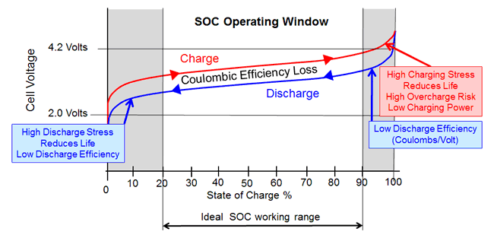

**Figure 1 –** Cell State of Charge vs. Cell Open Circuit Voltage [19].

Manufacturing and operating condition variances between individual cells leads to capacity variations in individual cells and thus the SoC of individual cells also varies over time. The inconsistency of SoC amongst individual cells in the battery pack is called cell or battery imbalance [21]. This becomes an issue because the battery pack’s maximum and minimum SoC is limited by the capacity of the smallest cell module if the pack is not balanced. This concept is most clearly demonstrated in figures 2b and 3b, which show a battery pack that are over-charged and over-discharged, respectively, due to cell imbalance. Figure 4 demonstrates how a pack falls out of balance due to self-discharged during storage.

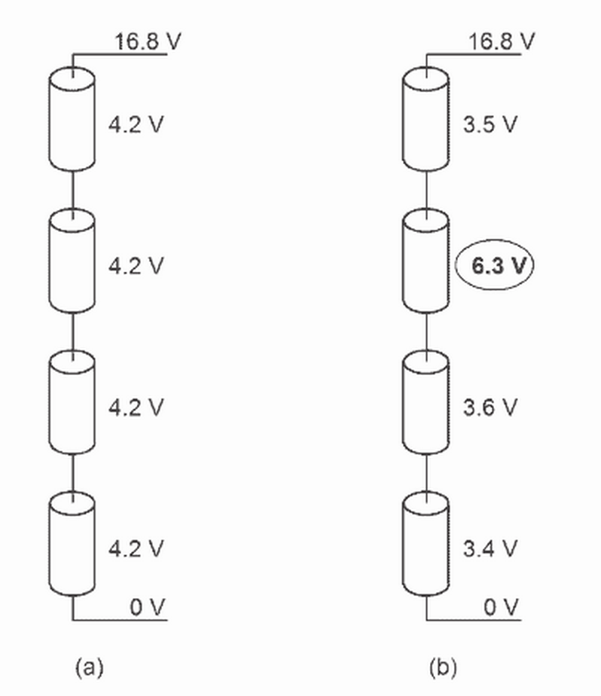

**Figure 2 –** (a) A Fully Charged, Balanced Four Cell Battery Pack; Versus (b) An Overcharged Battery Pack Due to an Overcharged Cell [21].

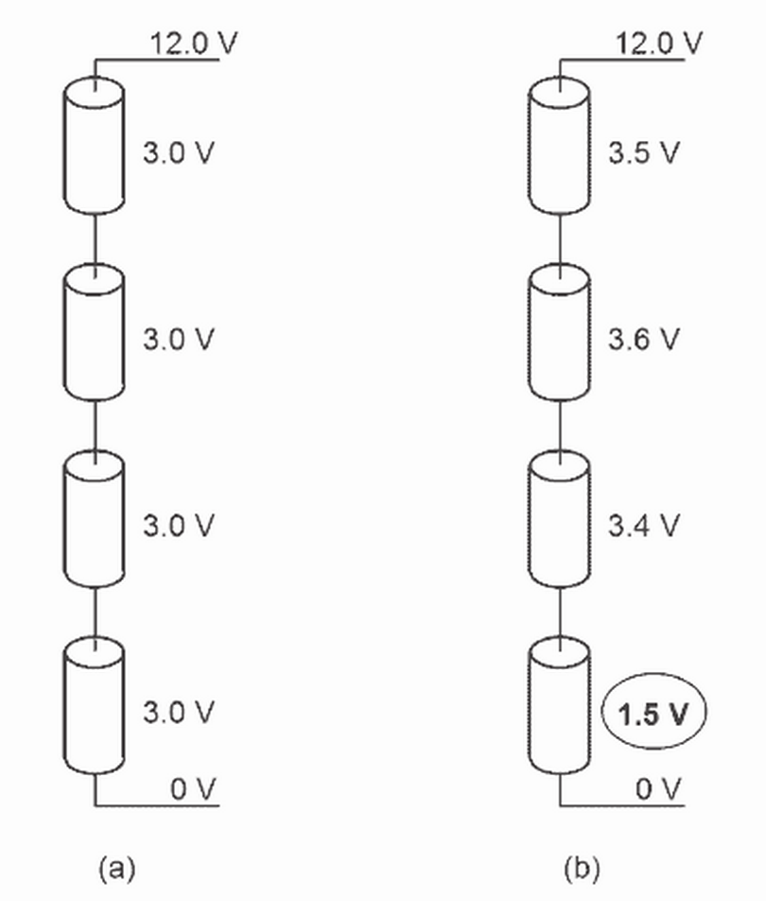

**Figure 3 –** (a) A Partially Discharged, Balanced Four Cell Battery Pack; Versus (b) An Over-Discharged Battery Pack Due to an Over-Discharged Cell [21].

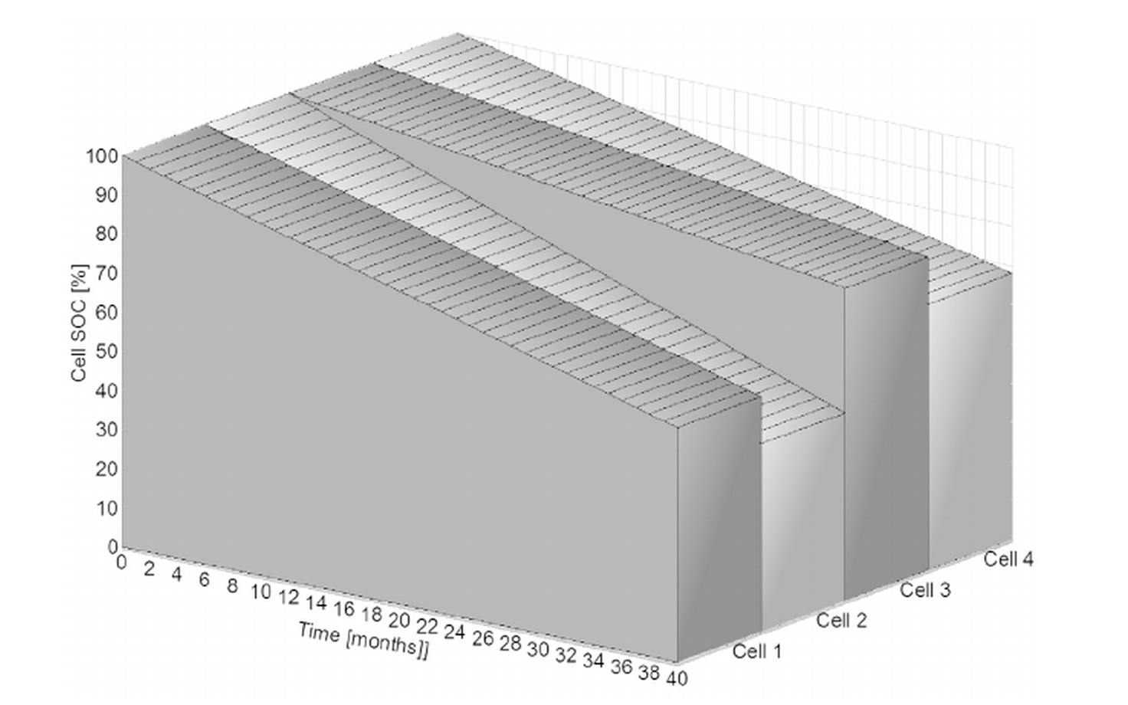

**Figure 4 –** Cell State of Charge Vs. Time in Storage [21].

The BMS’s cell balance hardware is responsible for maintaining pack balance. For cost and development time reduction purposes, the BMS will utilize passive cell balancing, and thus can only balance the pack during charging, not discharging.

State of Health estimation is useful for determining the pack’s remaining useful lifetime and its total charge capacity. Estimation of SoH will be the responsibility of the BMS’s master microcontroller in conjunction of the estimates made by the system’s analog front-end measurements.

The BMS will also be responsible for allowing a user to completely power the rover off using an emergency stop button. This will be the responsibility of the master microcontroller and the pack load switch, as well as an externally mounted emergency stop button.

Finally, it is critical that the BMS provide easily consumable telemetry data to the rover’s operator so that they may make informed decisions based on the battery pack’s current state. This will occur in two ways: first through immediately visible indicator hardware built into the battery pack, and second through serial telemetry reported back to the rover’s base station.

In addition to these functional requirements, it is critical that the system’s total component cost is under approximately $200; fits within an area of approximately 40 square inches; has a total weight of less than 1kg; and has a minimal energy drain on the battery pack, especially when the rover is power off.

**System Architecture**

Adsfads

**Monitoring Analog Front-End**

The BMS must make a large number of sensitive analog measurements to function properly, including voltage, current, and temperature measurements. Additionally, in order to perform cell balancing, the BMS must drive a large number of balancing switches. Due to the sheer number of analog measurements that are necessary, it is impractical to make all of these connections directly to a microcontroller unit’s ADC. The analog data sources proposed for this system are listed in table 1 below.

|  |  |  |
| --- | --- | --- |
| **Data Source** | **Number of Independent Measurements** | **Voltage Measurement Range (V)** |
| Cell Voltage | 8 to 12 (same as number of cells) | 0 to 4.5 (absolute limit)  2.5 to 4.2 (typical) |
| Pack Current | 1 | -5 to 5 (dependent on sensor) |
| Pack Voltage | 1 | 0 to 50 (scaled to 0 to 5 or 0 to 3.3) |
| Charger Output Current | 1 | - 5 to 5 (dependent on sensor) |
| Charger Input Voltage | 1 | 0 to 50 (scaled to 0 to 5 or 0 to 3.3) |
| System Output Voltage | 1 | 0 to 50 (scaled to 0 to 5 or 0 to 3.3) |
| Temperature | 2 | 0 to 3.3 or 0 to 5 |

**Table 1 –** Analog Data Sources Measured by the BMS.

Since as many as 19 different analog data sources may be measured by the BMS at any given time, it is necessary to multiplex the channels of the master microcontroller’s ADC. High quality analog multiplexers are often expensive, however, and require this approach requires the microcontroller to dedicate processor cycles to MUXing and analog-to-digital voltage conversion. Additionally, it poses a safety hazard by potentially exposing the low-voltage electronics of the microcontroller to full pack voltage (potentially over 50V). An alternative solution to a multiplexer is the use of a dedicated analog front-end ASIC that would make measurements, perform analog-to-digital conversion, and provide an isolated digital interface to the microcontroller.

Linear Technology’s LTC6802 Battery Stack Monitor IC has been selected for this application [13]. As an analog front-end IC, it can measure 2 to 12 cell voltages, perform passive balancing on 2 to 12 cells, and measure temperature from two external temperature sensors. It is daisy-chainable if additional measurements are necessary and provides a serial data interface to the master microcontroller. Figure 1 shows a high-level overview of the IC’s typical application. Figure 2 shows the IC’s pinout.

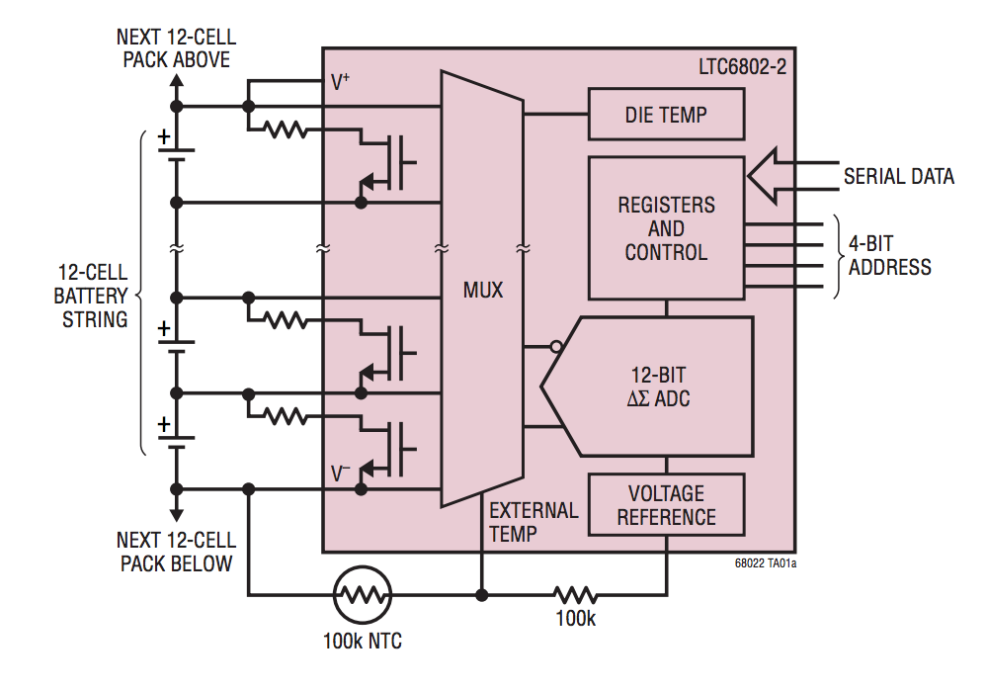

**Figure 1 –** Typical Application of the LTC6802-2.

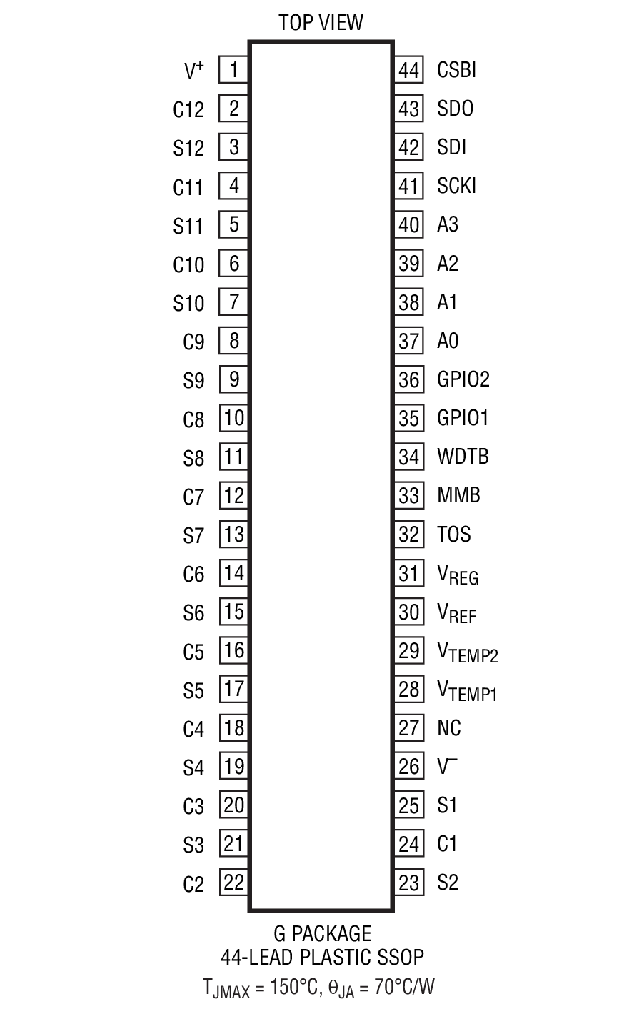

**Figure 2 –** Pinout of the LTC6802-2.

For the purposes of this application each connection between a cell module and the IC consists of a one-pole RC filter, transient voltage suppression circuit, and an off-IC balancing circuit. An example of one such circuit is shown in figure 3 below. This circuit is repeated for each of the eight cell modules in the pack.

The RC filter is used to suppress noise in the cell voltage measurements that is common when the pack is exposed to load transients. Values of 100 Ohms for the resistor and 100nF for the capacitor were selected to produce a low-pass filter with a cutoff frequency of approximately 16kHz. A large capacitor was not used in order to allow the LTC6802 IC to more easily detect cell measurement line disconnections [13].

A simple zener diode between cell filter nodes serves as transient voltage snubber circuit.

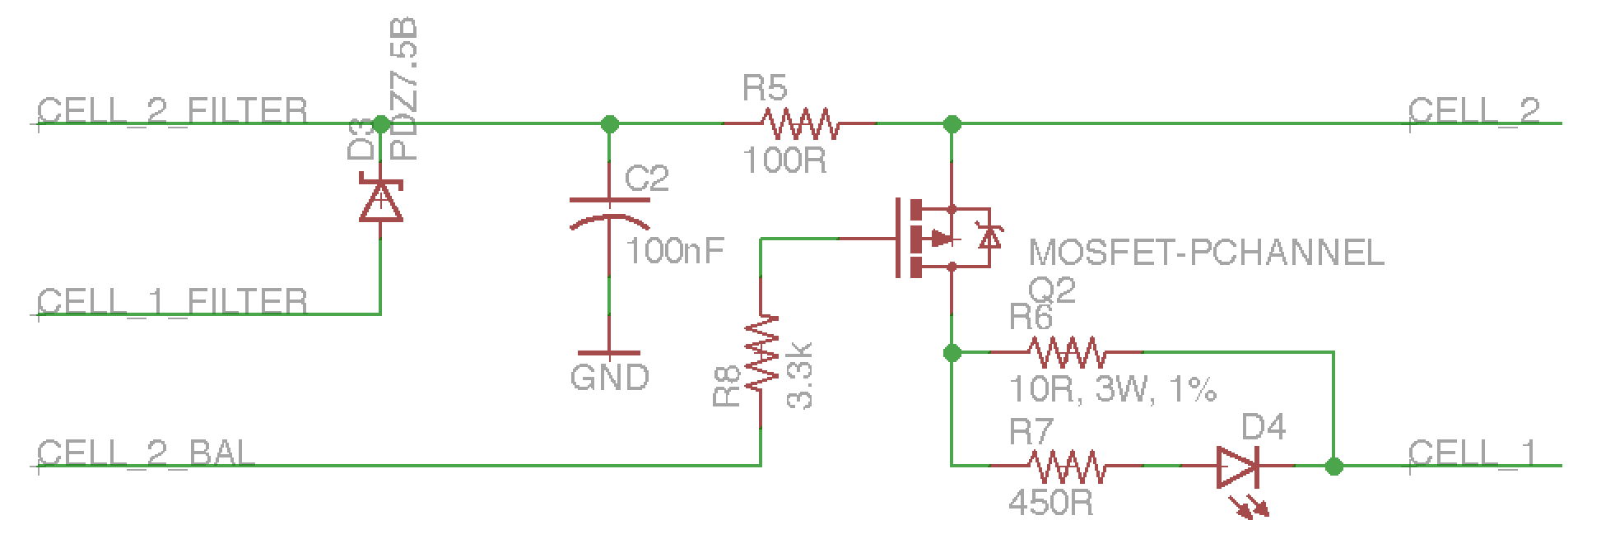

**Figure 3 –** Cell Module Interface Circuit.

Finally an external MOSFET and power resistor were included for passive cell balancing. Although the IC is capable of performing balancing without external hardware, its maximum balancing current is limited to 50 to 100mA (depending on the exact balancing conditions). This is due to the IC’s thermal dissipation characteristics, as shown in figure 4. The IC’s typical internal cell discharge current may be determined from the graph in figure 5.

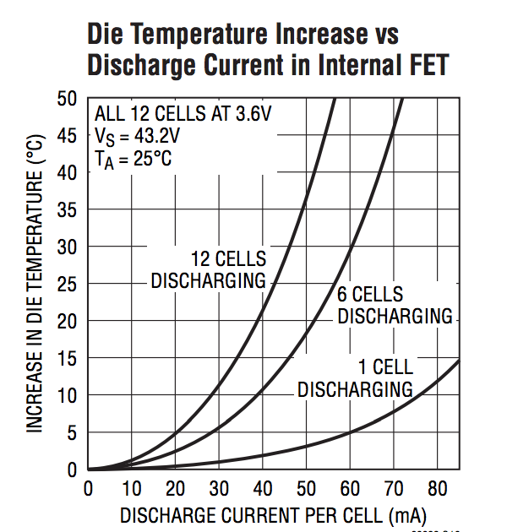

**Figure 4 –** LTC6802 Temperature Characteristics vs. Cell Discharge Current.

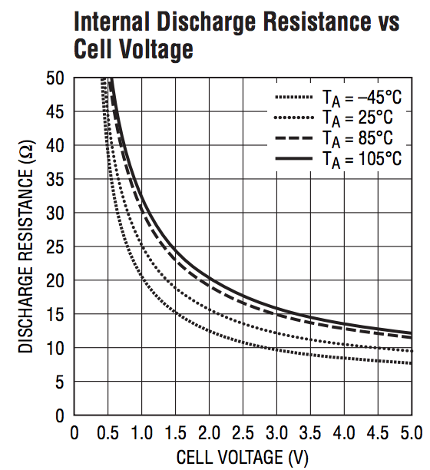

**Figure 5 –** The LTC6802’s Internal Discharge Resistance vs. Battery Cell Voltage.

The external balancing circuit consists of a small SOT23 package P-Channel MOSFET driven by the LTC6802 IC and a 10-Ohm, 3W, through-hole power resistor. For a cell voltage of 4V, this allows for a balancing current 400mA without overheating issues. Additionally, a small LED is connected in parallel to the power resistor to provide a visual indication that the balancing circuit is active.

For the purposes of battery pack thermal monitoring (and with cooling fans, management) two external NTC thermsistors may be connected to the LTC6802 IC as shown in figure 6. The NTC is connected in a voltage divider configuration to the IC’s analog voltage reference and measured by its on-board ADC. A voltage buffer circuit is included between the IC’s analog reference and the temperature sensor in order to better support a range of NTC resistor values. The “Temp_1” and “Temp_2” nets are connected to the IC’s temperature VTEMP1 and VTEMP2 pins, respectively.

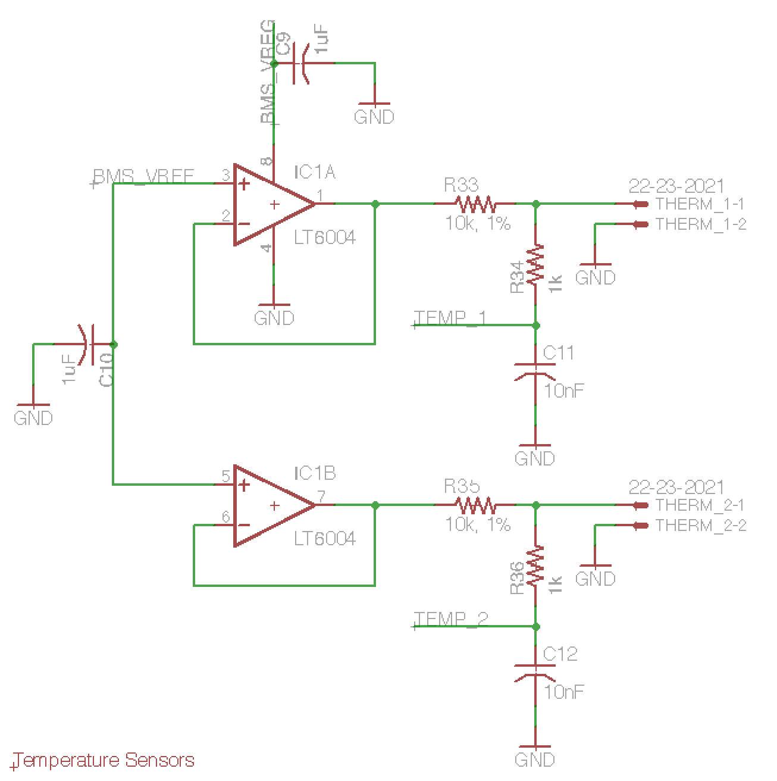

**Figure 6 –** Supporting Circuitry for External NTC Thermsistors.

In addition to cell voltage measurements, total pack voltage may be measured by the master microcontroller directly through a resistor divider network. The divider network scales the pack’s maximum voltage of 33.6V to under the 5V maximum of the master microcontroller’s ADC.

A hall-effect sensor is responsible for making pack voltage measurements and reporting them to the master microcontroller. The ACS770 has been selected for this application as it can support the full pack current of 200A in both directions (charging and discharging), is easily powered from a 5V DC supply, and outputs and analog voltage between 0V and 5V corresponding to total pack current [22]. Figure 7 depicts the circuitry support pack voltage and current measurements.

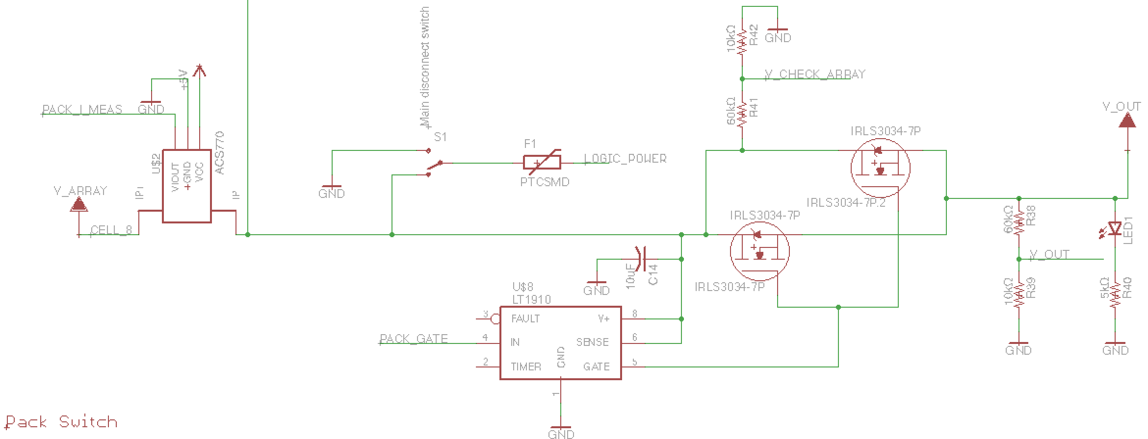

**Figure 7 –** Pack Current and Voltage Measurements; Load Switch MOSFET.

The analog front-end IC is only capable of supporting analog signal I/O for the BMS, it does not have any inherent battery management or protection logic built-in. This is the responsibility of the BMS’s master microcontroller. Thus it is necessary to provide a digital interface between IC and the microcontroller. For the LTC6802 this interface is very similar to SPI, and is depicted in figure 8 below.

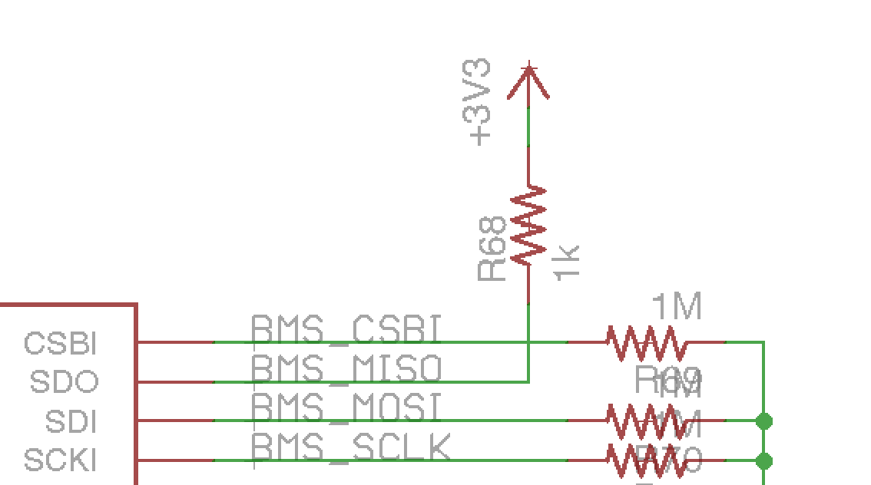

**Figure 8 –** LTC6802 to Microcontroller Serial Data Interface.

**Microcontroller**

Although the analog front-end IC is useful for aggregating battery pack data, it cannot make decision about the pack on its on. A microcontroller unit is necessary for monitoring pack operating state, activating balancing circuitry, controlling charging, and connecting and disconnecting the pack from its load. The I/O requirements for the microcontroller are summarized in table 2.

|  |  |  |
| --- | --- | --- |
| **Function** | **Type of I/O Port** | **Quantity of Ports/Pins** |
| Analog Front-End Communication | SPI | 1 |
| Cooling Fan Control | PWM | 4 |
| Cooling Fan Speed Feedback | GPIO | 4 |
| Buzzer Alarms | PWM | 2 |
| LED Gauge | GPIO | 4 |
| Emergency Stop Input | Digital Input – Interrupt | 2 |
| Pack Current Measurement | ADC | 1 |
| Pack Voltage Measurement | ADC | 1 |
| Pack Switch | GPIO | 1 |
| Pack Output Voltage Measurement | ADC | 1 |
| Charger Control | PWM | 1 |
| Charger Current | ADC | 1 |
| Charger Input Voltage Measurement | ADC | 1 |
| Serial Debug Port | USB | 1 |
| External Communication | Ethernet | 1 |
| External Power Supply Communication | GPIO | 2 |
| External LCD Screen | GPIO | 11 |

**Table 2 –** Microcontroller I/O Requirements.

In addition to meeting these I/O requirements, the microcontroller needs to operate at sufficiently high speed to frequently monitor the pack’s state, enable/disable balancing, update the charger power converter control loop, and maintain external communications. A microcontroller with a clock speed of at least 16MHz should be capable of this. Additionally, the microcontroller should be low power and capable of entering a low power sleep mode, as it will always be operating once installed in the pack. For ease of prototyping, it is also ideal if a development board is available for the microcontroller.

The MSP432P401R by Texas Instruments meets these requirements. It is part of TI’s MSP432 family of microcontrollers, a hybrid of the ubiquitous ARM architecture and TI’s low power MSP430 architecture. The microcontroller operates at up to 48MHz, meets the I/O requirements (with the exception of not having an on-board Ethernet PHY module), and consumes 90μA/MHz in low power mode [14]. Texas Instruments also produces a low cost development board targeting the microcontroller. The connections between the microcontroller’s I/O ports and the BMS hardware are described in table 3. Only pins made accessible by the Launchpad development board are listed [15].

|  |  |  |  |
| --- | --- | --- | --- |
| **Pin** | **Functionality** | **Relevant Hardware Peripherals** | **Connection** |
| 1.5 | Digital Input (Interrupt) |  | E-Stop 1 Input |
| 1.6 | Digital Input (Interrupt) |  | E-Stop 2 Input |
| 1.7 | GPIO |  | External Power Supply Communication |
| 2.3 | GPIO |  | External Power Supply Communication |
| 2.4 | PWM | TA0, CCR1 | Fan 1 Speed Control |
| 2.5 | PWM | TA0, CCR2 | Fan 2 Speed Control |
| 2.6 | PWM | TA0, CCR3 | Fan 3 Speed Control |
| 2.7 | PWM | TA0, CCR4 | Fan 4 Speed Control |
| 3.0 | GPIO |  | Fan 4 Tachometer |
| 3.2 | GPIO |  | Fan 3 Tachometer |
| 3.3 | GPIO |  | Fan 2 Tachometer |
| 3.5 | GPIO |  | LCD Screen RS |
| 3.6 | GPIO |  | LCD Screen R/~W |
| 3.7 | GPIO |  | LCD Screen EN |
| 4.0 | GPIO |  | LCD DB[0] |
| 4.1 | GPIO |  | LCD DB[1] |
| 4.2 | GPIO |  | LCD DB[2] |
| 4.3 | GPIO |  | LCD DB[3] |
| 4.4 | GPIO |  | LCD DB[4] |
| 4.5 | GPIO |  | LCD DB[5] |
| 4.6 | GPIO |  | LCD DB[6] |
| 4.7 | GPIO |  | LCD DB[7] |
| 5.0 | GPIO |  | Fan 1 Tachometer |
| 5.1 | ADC | ADC4 | Charger Voltage |
| 5.2 | ADC | ADC3 | Charger Current |
| 5.3 | ADC | ADC2 | System Output Voltage |
| 5.4 | ADC | ADC1 | Pack Voltage |
| 5.5 | ADC | ADC0 | Pack Current |
| 5.6 | PWM | TA2, CCR1 | Buzzer 1 |
| 5.7 | PWM | TA2, CCR2 | Buzzer 2 |
| 6.0 | GPIO |  | Pack Load Switch |
| 6.1 | Digital Input (Interrupt) |  | Wiznet Data Available Interrupt |
| 6.2 | SPI SS | eUSCI_B1 | LTC6802 CSBI |
| 6.3 | SPI SCLK | eUSCI_B1 | LTC6802 SCKI |
| 6.4 | SPI MOSI | eUSCI_B1 | LTC6802 SDI |
| 6.5 | SPI MISO | eUSCI_B1 | LTC6802 SDO |
| 6.6 | Digital Input (Interrupt) |  | LCD/LED Indicator On/Off Button |
| 6.7 |  |  |  |
| 7.0 |  |  |  |
| 7.1 |  |  |  |
| 7.2 |  |  |  |
| 7.3 |  |  |  |
| 7.4 |  |  |  |
| 7.5 |  |  |  |
| 7.6 |  |  |  |
| 7.7 |  |  |  |
| 8.0 | PWM | TA1, CCR0 | Charger Power Converter Control |
| 8.2 |  |  |  |
| 8.3 |  |  |  |
| 8.4 |  |  |  |
| 8.5 |  |  |  |
| 8.6 |  |  |  |
| 8.7 |  |  |  |
| 9.0 | GPIO |  | Wiznet Reset |
| 9.1 |  |  |  |
| 9.2 |  |  |  |
| 9.3 |  |  |  |
| 9.4 | SPI SS | eUSCI_A3 | Wiznet SS |
| 9.5 | SPI SCLK | eUSCI_A3 | Wiznet SCLK |
| 9.6 | SPI MISO | eUSCI_A3 | Wiznet MISO |
| 9.7 | SPI MOSI | eUSCI_A3 | Wiznet MOSI |
| 10.0 | GPIO |  | LED Shift Register CLR |
| 10.1 | GPIO |  | LED Shift Register RCK |
| 10.2 | GPIO |  | LED Shift Register SER_IN |
| 10.3 | GPIO |  | LED Shift Register SRCK |
| 10.4 |  |  |  |
| 10.5 |  |  |  |

**Table 3 –** Microcontroller I/O Connections. Unused Pins are Shaded.

**Pack Load Switch**

The master microcontroller is responsible for connecting/disconnecting the battery pack from its load by commanding the output of a MOSFET driver IC. The microcontroller will switch the pack off when the battery pack is operating outside of its safe operating area or if the emergency stop button is activated. The hardware responsible for this functionality is shown in figure 7.

In order to handle the 200A continuous discharge the pack is capable of sustaining, as well as larger transient load currents, the load switch consists of two International Rectifier IRLS3034 Power MOSFETs connected with drain and source junctions in parallel [16]. The MOSFETs case temperature characteristics versus drain current are shown in figure 8. Each MOSFET should be capable of handling 200A independently, thus together they should be able to sustain load transients on the order of 400A without significant overheating issues. The MOSFETs are connected in parallel without load balancing resistors because in general they will be operated in the saturation region with low Rdss(on), and thus their negative temperature coefficient properties should ensure proper load current balancing between the two devices [17].

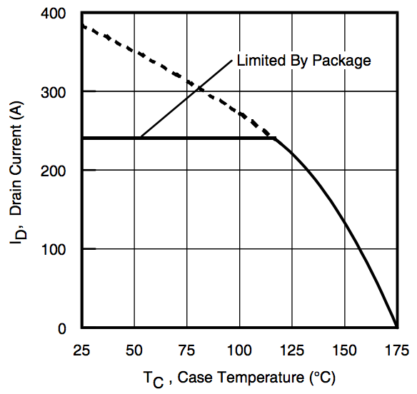

**Figure 8 –** IRLS3034 Case Temperature vs. Drain Current.

The two MOSFETs will be driven by a single LT1910 high side MOSFET driver IC [18]. As the FETs will generally operate in the saturation for long periods of time, turn-on time, and therefore gate driver current and gate charge are not serious design concerns. The ability of this MOSFET and driver configuration to sustain 200A of load current continuously has been empirically verified by the team in past years.

**Cooling Fans**

In order to ensure the battery pack is properly cooled when under heavy load conditions, connections for four external cooling fans have been made available. The four fans can have their speed individual controlled by driving an onboard MOSFET with PWM. Additionally, the master microcontroller can measure tachometer feedback from each fan. The fans are connected to the board via a standard 0.1” pitch three-pin connector. Support hardware for this configuration is shown in figure 9.

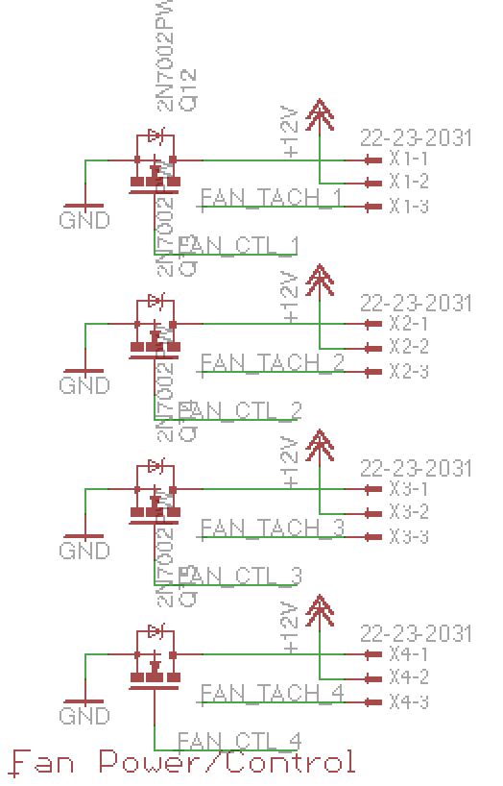

**Figure 9 –** Cooling Fan Connectors.

**Indicators**

Two types of user interface indicators are incorporated into the design to provide the user with information about the state of the battery pack: a 10 segment LED bar graph and a 16x2 character LCD display.

The LED bar graph will serve as a state of charge indicator with each segment corresponding to 10% of the total state of charge. The LED bar graph will be controlled by a serial data stream from the master microcontroller to a high power, open-drain shift register which will drive the LEDs. This circuit is depicted in figure 10 and an example of the bar graph component is shown in figure 11. The shift register component is the TI TLC6C5912-Q1 and the bar graph is the Kingbright DC7G3HWA [23][24]. The shift register output enable pin is connected to an external momentary SPST switch so that the indicator is only lit when the user holds down on the button, preventing unnecessary drain on the battery pack.

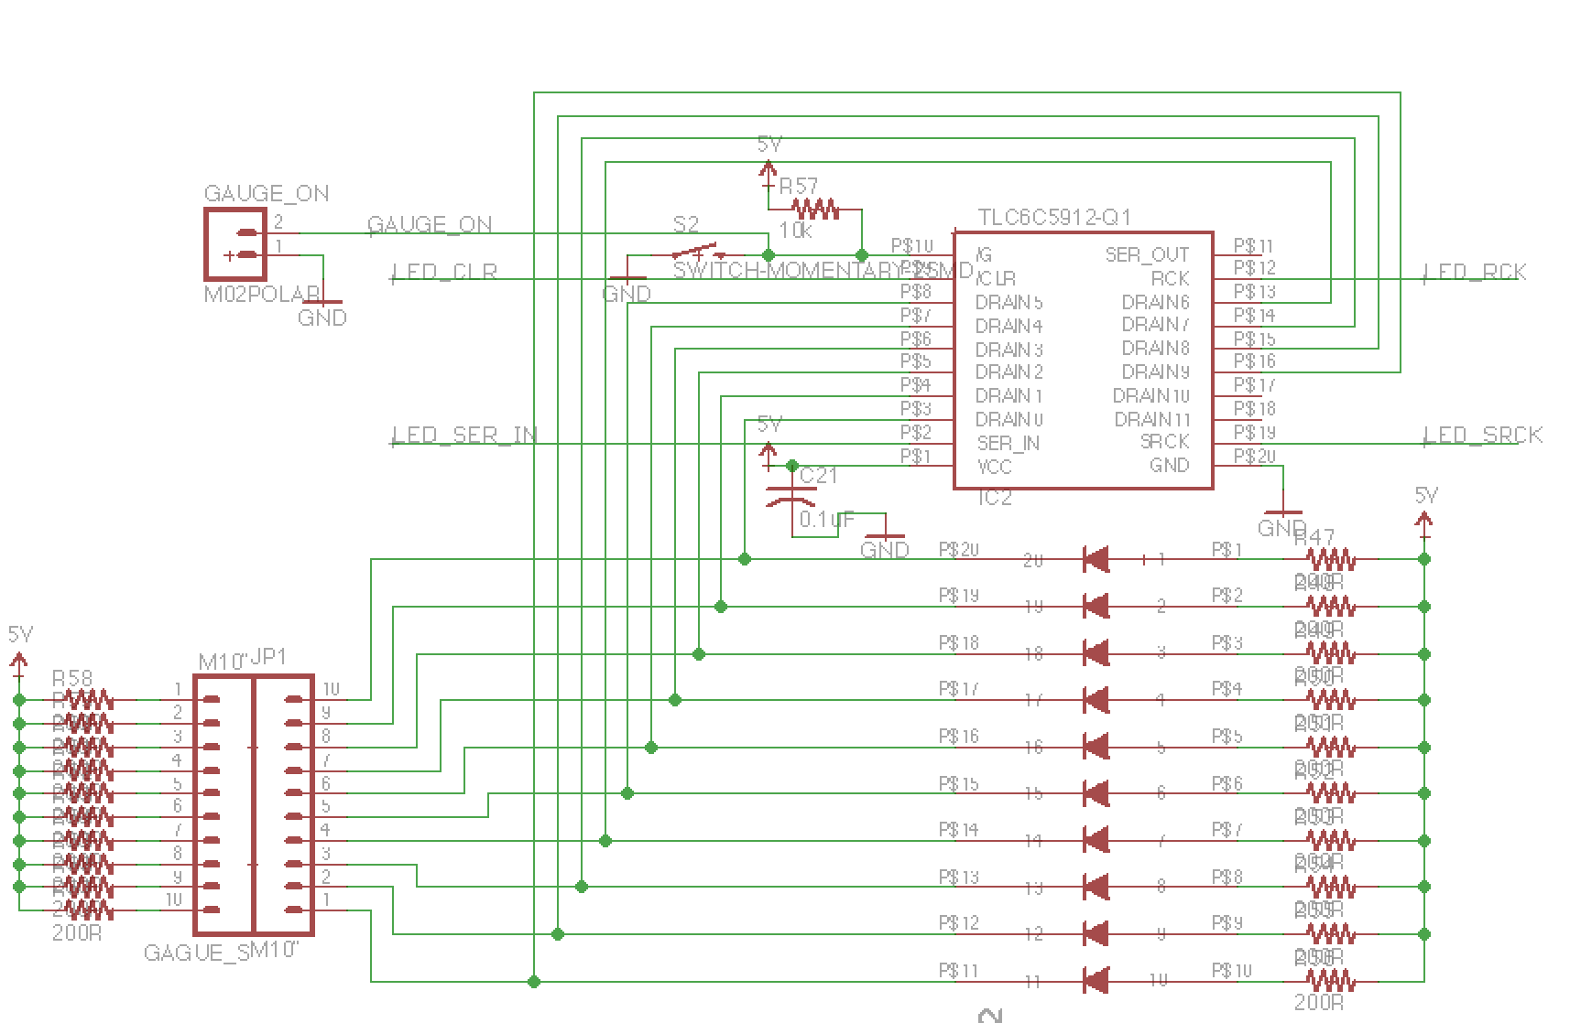

**Figure 10 –** LED Bar Graph Indicator, Shift Register Driver, External Mounting Connectors, and Indicator Momentary Power Switch.

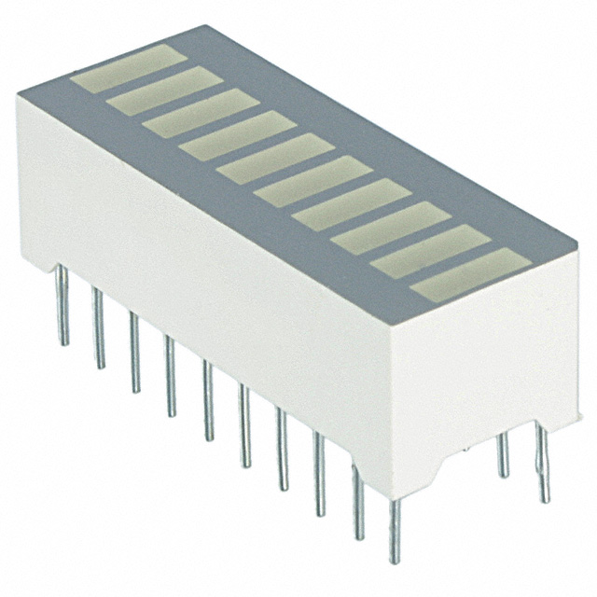

**Figure 11 –** Sample LED Bar Graph Component, Unpowered.

The second indicator will be a 16x2 character LCD display. This will provide simple telemetry data about the battery pack’s status to the user.

**Serial Data Interface**

The master microcontroller makes two telemetry/telecommand serial data interfaces available: a USB serial logging interface for reading data from a PC and an RS-485 serial interface for communicating with the battery pack’s power board (which is the BMS’s primary load). The serial interface circuitry between the BMS and power board is shown in figure 12 below.

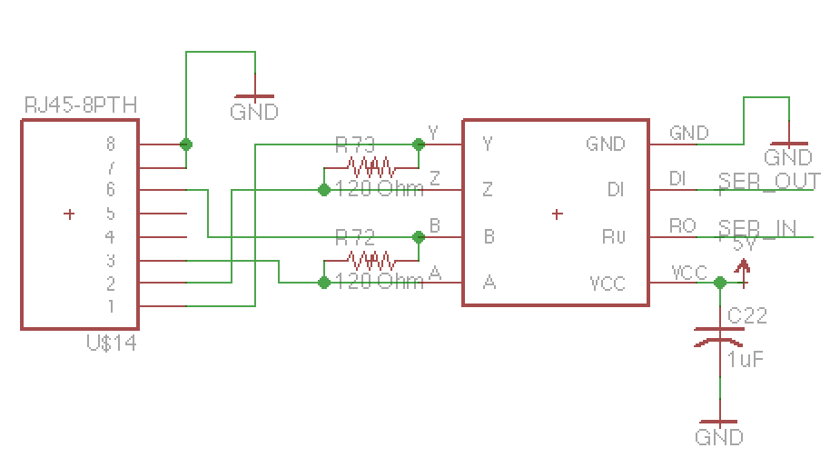

**Figure 12 –** RS-485 Serial Data Interface to BMS Master Microcontroller.

**System Power Supply**

Alsdjfladskjfkalds

**Software**

Afdjlaskfjaldskjfkls

**Battery Charger**

An integrated charger for the battery pack is desired in order to charge the batteries at their rated-charging speed and to simplify the charging process for the end-user. The preliminary charger will accept a DC-input greater than pack voltage for a buck-converter based charger. A future revision of the charger could be a buck-boost converter that would also accept charging voltages below pack voltage.

**Charging Requirements**

The selected cells are rated for two charging algorithms: a standard charge and a fast charge. As their names indicate, the standard charging algorithm is slower, but results in increased cell lifetime; while the fast charge is significantly faster but will reduce cell lifetime.

The standard charging algorithm consists of two phases: the constant current (CC) phase and the constant voltage phase (CV). For a standard charge, CC charging first takes place at 1250mA (per parallel cell), then CV charging takes at 4.2V (per series cell) until charging current tapers to 50mA per cell. For a fast charge, CC charging first takes place at 4000mA (per parallel cell), then CV charging takes at 4.2V (per series cell) until charging current tapers to 100mA per cell. After fast charging the batteries must rest for 10 minutes.

Since the fast charging algorithm places the greatest demand on the battery charger, it will be used for determining battery charger requirements. For the proposed 10 parallel/8 series (10p8s) battery pack, the minimum pack voltage will be 20V and the maximum pack voltage will be 33.6V. Thus the charger must be capable of constant voltage charging at 33.6V. Since there are ten cells in parallel, the charger must be capable of sourcing 40A during CC charging. The worst-case power draw on the charger occurs during a 33.6V, 40A charging period (an unlikely load point for the battery pack), which is equal to 1344W. Design goals for the charger are summarized in table 1 below.

|  |  |  |  |  |
| --- | --- | --- | --- | --- |
| **Parameter** | **Minimum** | **Nominal** | **Maximum** | **Units** |
| Output Voltage | 20.0 |  | 33.6 | V |
| Output Current | 12.5 |  | 40.0 | A |
| Input Voltage | 35 |  | 50 | V |
| Rated Power |  | 1350 |  | W |
| Weight |  | 200 | 1000 | g |
| Board Area |  |  | 24 | Sq. in. |

**Table 1 –** Charger Design Parameters

**Buck-Converter Design**

The buck-converter topology was selected for the first revision of the battery charger due to its simplicity. A high-level converter design is presented in this section that assumes nearly ideal components. This serves as the base design for the more detailed, non-ideal analysis in the subsequent sections.

A conceptual equivalent circuit for a buck converter is shown in figure 1. It consists of an input voltage source, a high frequency switch, a rectifying diode, a switching inductor and filter capacitor (which together form a second order low pass filter), and a load resistor. The goal of the design process covered in this section is to select an appropriate inductor value, switching frequency, and filter capacitor value which function over the full operating range of the converter. Since this converter is being used for battery charging, it will need to operate over a few particular operating points that represent the constant-current and constant-voltage charge curves shown in figure 2. The worst-case values for these operating points are summarized in table 2. Note that for these initial calculations it is assumed that the on-state resistance of the converter’s switch is negligible and that the series resistance of the inductor is zero. Additionally the battery pack will be approximated as an equivalent load resistance. More accurate models are presented later.

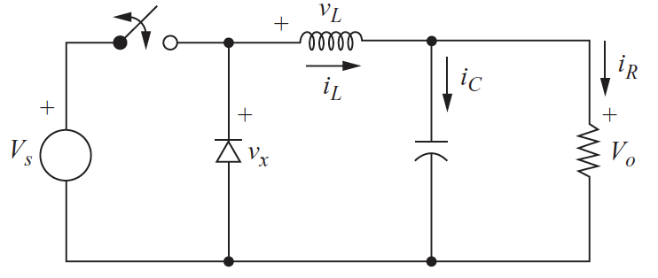

**Figure 1 –** Simplified Equivalent Circuit of a Buck Converter [25].

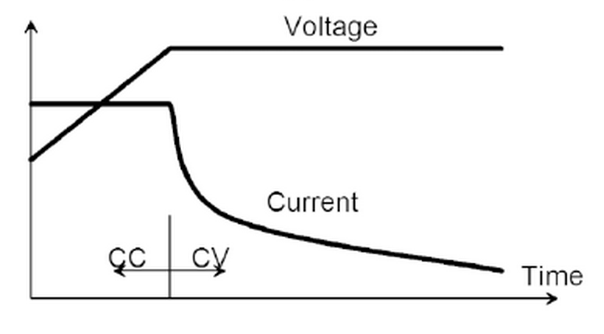

**Figure 2 –** Current and Voltage Operating Points for CC and CV Charging [21].

|  |  |  |  |  |
| --- | --- | --- | --- | --- |
| **Load Case** | **Control Mode** | **Input Voltage** | **Output Voltage** | **Output Current** |
| CC Charging | Current Mode | 36V | 20V to 33.6V | 40A |
| Current Mode | 48V | 20V to 33.6V | 40A |
| CV Charging | Voltage Mode | 36V | 33.6V | >= 500mA |
| Voltage Mode | 48V | 33.6V | >= 500mA |

**Table 2 –** Buck-Converter Operating Points.

First and inductor value and switching frequency must be chosen. Since there is a trade-off between inductor size and switching frequencies, inductor values were calculated over a series of potential frequencies. The final inductor and switching frequency is a compromise between cost and performance and is explored in detail in the section titled *Inductor Selection*. The following design calculations are based on an operating point analysis for continuous inductor current presented in Hart’s *Power Electronics* [25]. First of all for the various load cases, the duty cycle must be considered. The switching duty cycle for the ideal buck converter is:

$$D=\frac{V_{o}}{V_{s}}$$

Where:

D = Duty Cycle (0 to 1 for 0% to 100% of switching period T)

Vo = Output Voltage

Vs = Input (Source) Voltage

Furthermore, the minimum inductor value for a given load, switching frequency, and duty cycle is:

$$L_{min}= \frac{\left(1-D\right)R}{2f}$$

Since our load’s equivalent resistance varies depending on the charger’s operating point, and a steady-state voltage and/or current instead define this operating point, the equation for minimum inductor value may be redefined in terms of load voltage and load current, Io:

The duty-cycle, output voltage, and output current are all related to one another. For voltage mode control (during CV charging), Vo will be held constant, leading to a variation in Io over the defined operating limits of the battery pack. For current mode control (during CC charging), the converter will attempt to hold Io constant by varying Vo over the operating limits of the battery pack. And regardless, the duty-cycle is a function of converter input and output voltages, as shown in equation 1. Since duty cycle is a direct function of the input and output voltage operating conditions, it is further useful to rewrite equation 3 using equations 1 to produce equation 4:

$$L_{min}=\frac{(1-\frac{V_{o}}{V_{s}})\frac{V_{o}}{I_{o}}}{2f}$$

$$L_{min}=\frac{\frac{V_{o}}{I_{o}}-\frac{V_{o}^{2}}{V_{s}I_{o}}}{2f}$$

In order to determine the necessary inductor size for various switching frequencies, it is easiest to break the converter into two operating cases: voltage mode control and current mode control. This means that one of the variables is held constant in equation 4, and thus makes the value of the inductor in equation a function of two variables. For constant current it is a function of output voltage and input voltage; for constant voltage it is a function of output current and input voltage. To make it possible to iterate over a series of frequencies, it is useful to breakdown the two above case into two more cases each, one for an input voltage of 36V and one for an input voltage of 48V. These voltages are selected for analysis, as they are common voltage levels for DC power supplies that will be used for the charger. Thus, the four possible load cases are summarized in table 3.

|  |  |  |  |  |  |
| --- | --- | --- | --- | --- | --- |
| **Load Case** | **Control Mode** | **Input Voltage (Vs)** | **Output Voltage (Vo)** | **Output Current (Io)** | **Switching Frequency (f)** |
| 1a | Current | 36V | *Variable* | 40A | *Variable* |
| 1b | Current | 48V | *Variable* | 40A | *Variable* |
| 2a | Voltage | 36V | 33.6V | *Variable* | *Variable* |
| 2b | Voltage | 48V | 33.6V | *Variable* | *Variable* |

**Table 3 –** Four Charger Load Cases for Analysis.

Inductor values for each the four cases listed in table 2 were calculated iteratively using the computer program GNU Octave [26]. These results are summarized in figures 4 through 7. The source code of the Octave program used for these calculations is included in Appendix A.

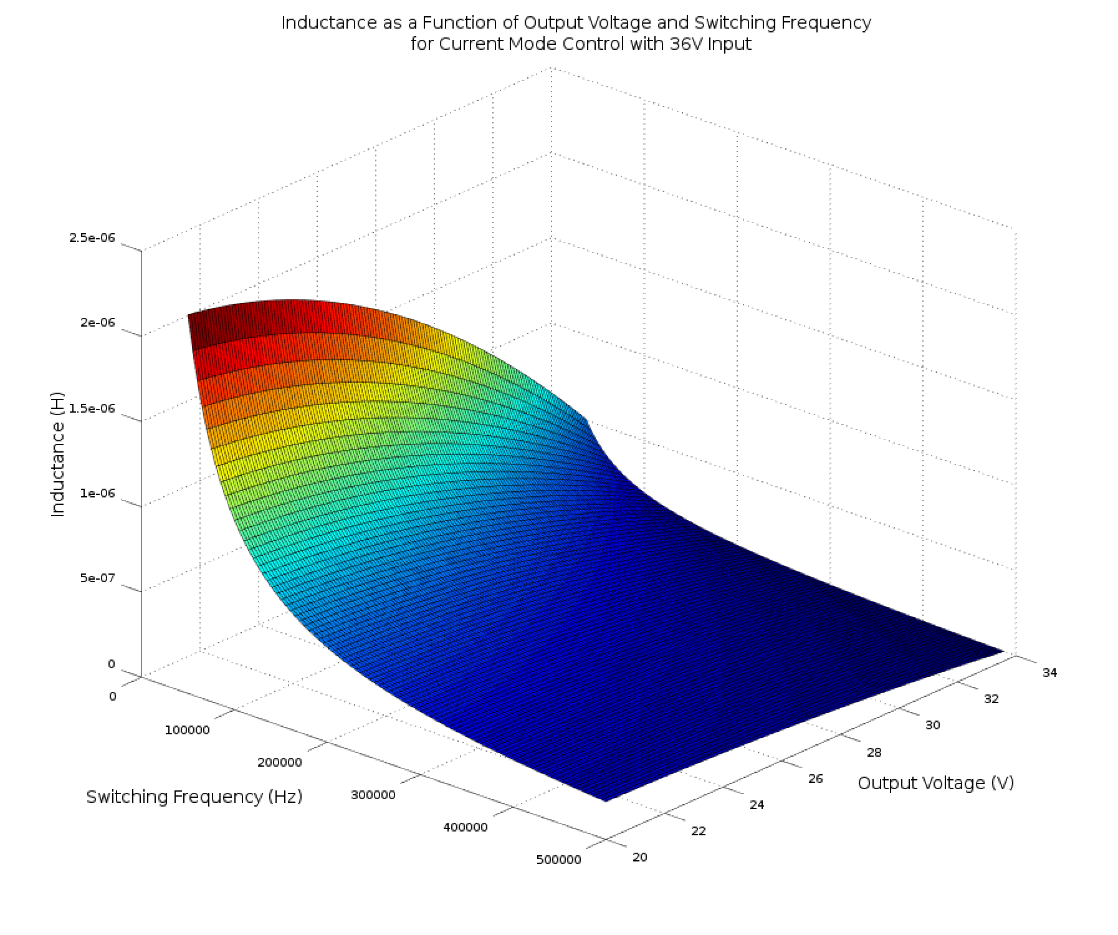

**Figure 4 –** Inductance Values for Load Case 1a.

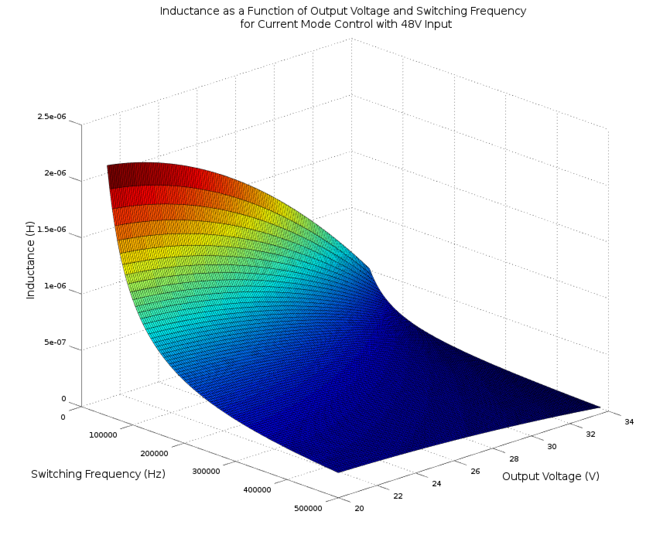

**Figure 5 –** Inductance Values for Load Case 1b.

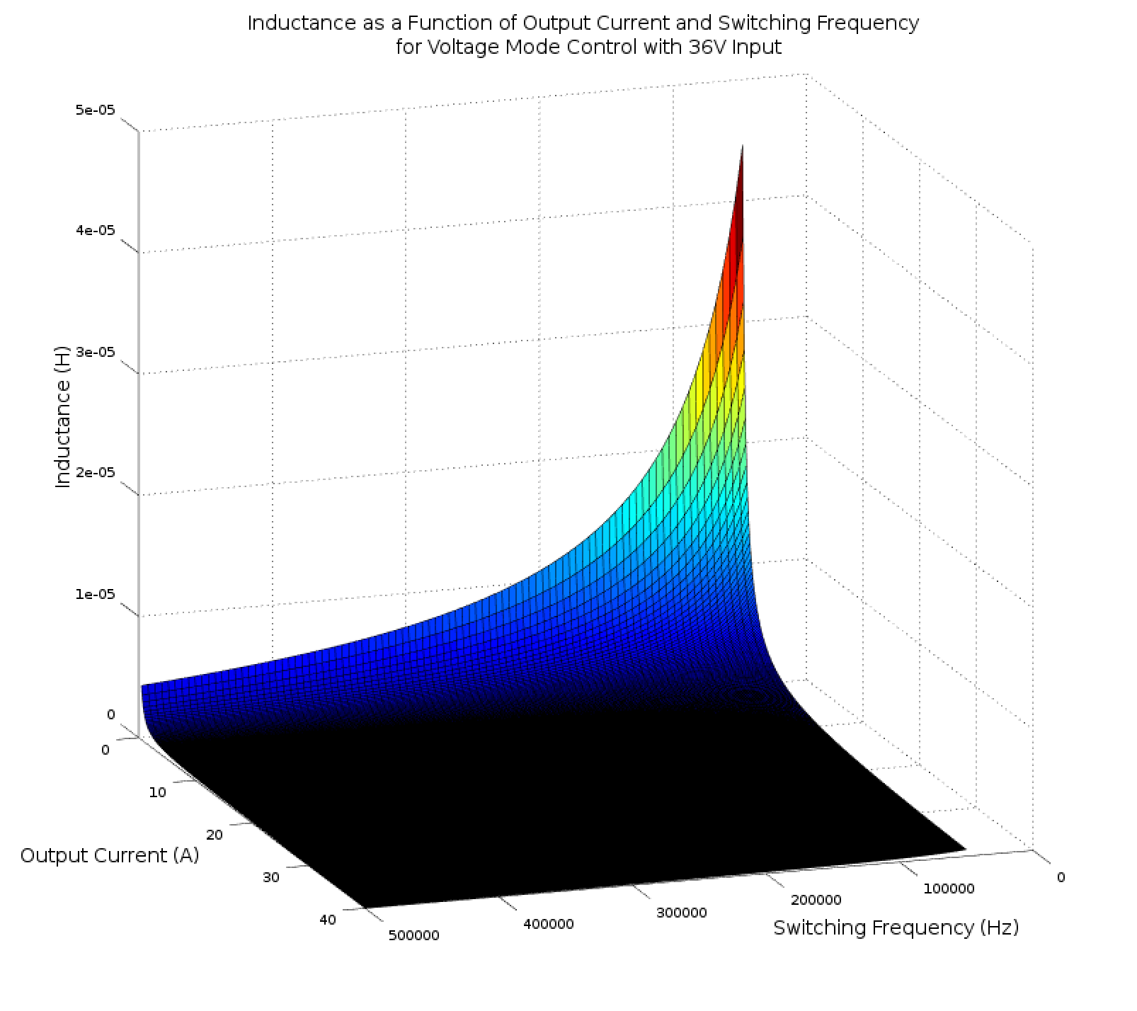

**Figure 6 –** Inductance Values for Load Case 2a.

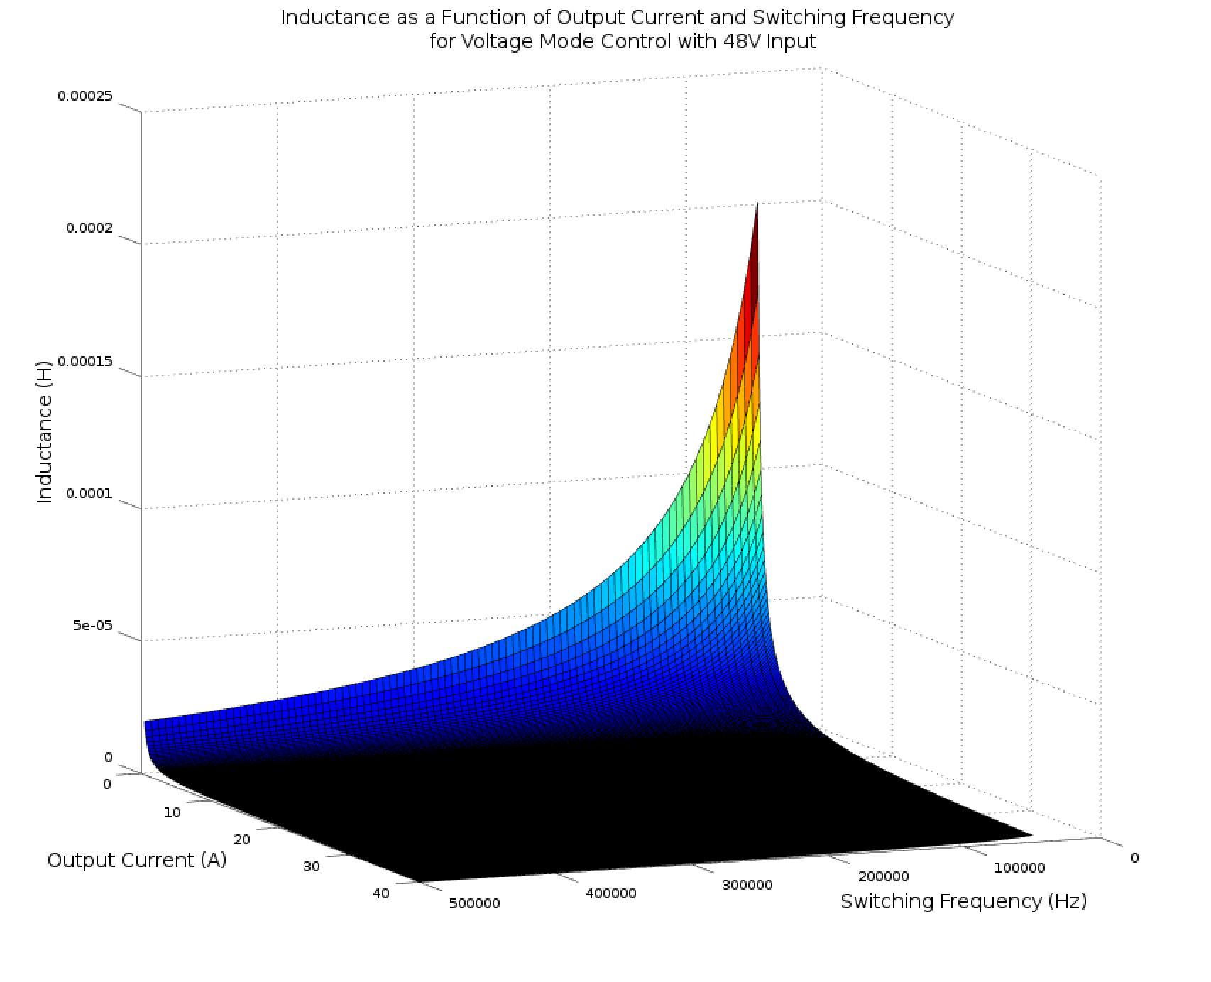

**Figure 7 –** Inductance Values for Load Case 2b.

From figures 4 through 7, it is clear that the worst-case load case for selecting the inductor size occurs at low output current values during constant voltage charging. It was worth noting that these calculations assume continuous inductor current, something that is not necessarily required under these light-load conditions. Regardless, for the worst case of a 33.6V output at 500mA, the inductance may be calculated for a series of switching frequencies. These results are summarized in table 4.

|  |  |
| --- | --- |
| **Switching Frequency** | **Minimum Inductance** |
| 50 kHz | 201.6 μH |
| 125 kHz | 80.64 μH |
| 250 kHz | 40.32 μH |
| 500 kHz | 20.16 μH |

**Table 4 –** Minimum Inductance vs. Switching Frequency for Worst-Case Load.

These potential inductor values are used in the Inductor Selection to determine an appropriate inductor value and switching frequency. There is a tradeoff between switching frequency and inductor value, as higher value inductors that are still capable of supporting high currents without significant resistive losses or core saturation are generally quite large. The maximum weight of the charger limits the options here. Additionally, higher operating frequency increases switching losses, in addition to many other issues. Thus the switching components limit the maximum feasible switching frequency.

The subsequent design of converter is dependent on the value of the inductor. The Inductor Selection section explains that a 22μH inductor was selected with a switching frequency in the range of 250kHz to 500kHz. This value is used for the remaining analysis in this section, although it would be trivial to recalculate the remaining parameters for a different inductor and switching frequency value.

Now the converter’s output capacitor filter size may be calculated. This may be accomplished for an ideal capacitor using the following equation [25]:

$$C=\frac{1-D}{8L(\frac{∆V_{o}}{V_{o}})f^{2}}$$

Where:

C = the output capacitance

ΔVo = the output voltage ripple

For a 10mV output ripple, this corresponds to a 29.0μF output capacitance.

Unfortunately, the equivalent series resistance (ESR) of the capacitor will also introduce some output ripple voltage. As a result, it is necessary to limit the ESR of the selected capacitor as well. While the effect of the ESR varies over the converter’s operating point, the worst case is described by the following equation:

$$∆V_{o}=r_{c}∆I_{l}$$

For 10mV maximum output ripple the maximum ESR is approximately 16.8mOhms.

**Inductor Selection**

The selected inductor is largely dependent on the selected switching frequency for the converter. Higher switching frequencies lead to higher switching losses and create more stringent requirements for the converter’s MOSFET switches and MOSFET drivers, however allow for the use of smaller magnetics. Lower switching frequencies require an inductor of higher rated inductance and thus a larger, heavier inductor. Inductors for various switching frequencies are presented in this section.

Based on the analysis in the previous section, a switching frequency of in the range of 50kHz to 500kHz is likely. The requirements for inductors for frequencies in this range are presented in table 2 below.

|  |  |  |  |  |
| --- | --- | --- | --- | --- |
| **Parameter** | **50kHz Inductor** | **125kHz Inductor** | **250kHz Inductor** | **500kHz Inductor** |
| Inductance (μH) | 132 | 88 | 44 | 22 |
| RMS Current (A) | 40 | 40 | 40 | 40 |
| Saturation Current (A) | 40 | 40 | 40 | 40 |
| Ripple Current (A) |  |  |  |  |

**Table 2 –** Inductor Requirements for Various Switching Frequencies.

Various suppliers were searched for inductors that meet the above requirements. The selected inductor for each switching frequencies was selected by best meeting the required electrical characteristics while minimizing cost, weight, and size. Possible inductors are presented in table 3 below. Values for the table were derived from the manufacturer datasheet tables and the curves shown in figures 1, 2, and 3.

|  |  |  |  |  |
| --- | --- | --- | --- | --- |
| **Parameter** | **50kHz Inductor** | **125kHz Inductor** | **250kHz Inductor** | **500kHz Inductor** |
| **Part Number** | WCM 306-8 | WCM 306-10 | WCM 306-13 | AGP4233-223ME |
| **Supplier** | West Coast Magnetics | West Coast Magnetics | West Coast Magnetics | Coilcraft |
| **Price ($)** |  |  |  |  |
| **Inductance (μH)** | 131 | 91 | 49 | 22 |
| **Inductance Tolerance** |  |  |  | +/- 10% |
| **Weight (g)** | 1000 | 1000 | 1000 | 135 |
| **DCR (mOhms)** | 2.80 | 1.89 | 1.03 | 2.95 |
| **Size - Length, Width, Height (cm)** | 7.75 x 7.24 x 7.62 | 7.75 x 7.24 x 7.62 | 7.75 x 7.24 x 7.62 | 4.22 x 3.58 x 2.80 |
| **RMS Current (A)** | 33.0 | 39.0 | 55.0 | 34.0 |
| **Saturation Current, 10% (A)** | 37 | 45 | 60 | 32.8 |
| **Saturation Current, 20% (A)** | 39 | 47 | 65 | 35.4 |
| **Saturation Current, 30% (A)** | 42 | 50 | 67 | 36.6 |
| **Ripple Current (A)** |  |  |  |  |
| **Temperature (C)** |  |  |  | 125 |

**Table 3 –** Selected Inductor Characteristics for Various Switching Frequencies[1][2].

The two best inductors for this application are the WCM-306-10 (a 91uH inductor produced by West Coast Magnetics) and the AGP4233-233ME (a 22 uH inductor produced by Coilcraft).

The WC Magnetics inductor is well suited for this application because it allows for a reasonable switching frequency (125kHz) while still meeting the current requirements of the converter (the 39.0Arms is the limiting current rating; the core will not saturate within the converter’s operating limits). Unfortunately this inductor is quite large, weighing 1kg and having a board surface area of 56.11cm2 (8.70in2). This makes the inductor ideal for an off-rover charger; however, it may prove to be too large for an integrated charger.

The Coilcraft inductor is also well-suited for this application largely due to small-size. It weighs only 135 grams and uses only 15.10cm2 (2.34 in2) of board space. This is 86% savings in weight and 73% savings in volume compared to the WC Magnetics inductor. Unfortunately this inductor is not capable of supporting the full rated current of the charger, limited by a 34.0Arms current and a 32.8A saturation current for a 10% loss of inductance. (More detailed analysis is required to demonstrate this inductors performance over various charger operating points due to the lower saturation current.)

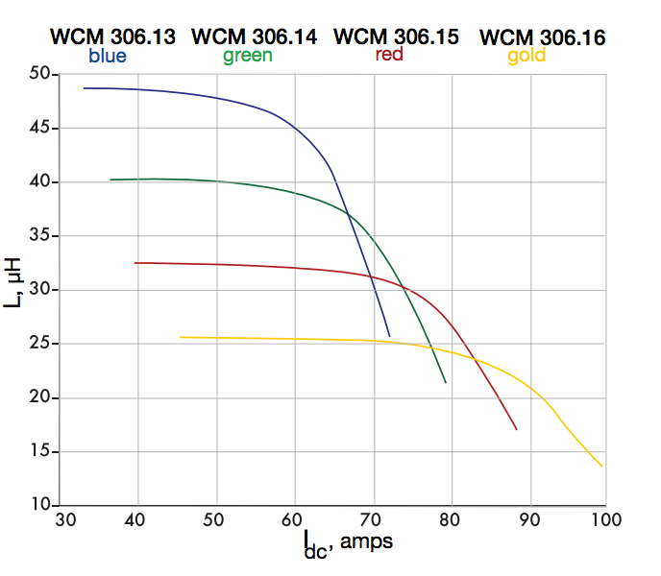

**Figure 1 –** Saturation Current for Inductor WCM 306.13.

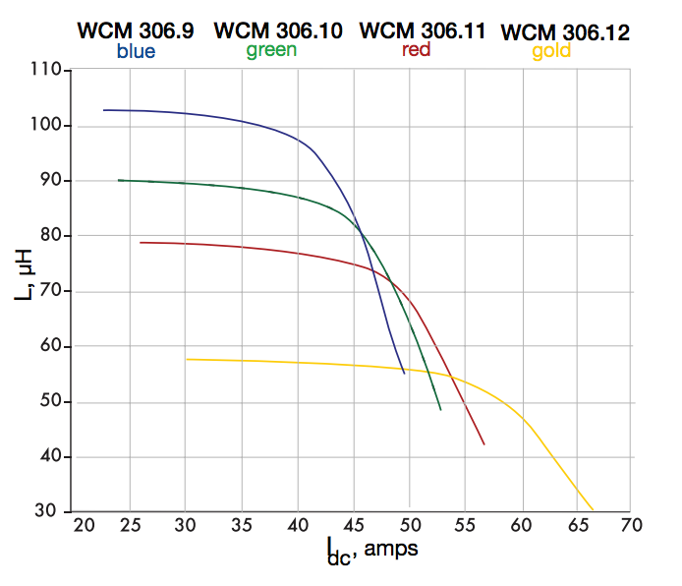

**Figure 2 –** Saturation Current for Inductor WCM 306.10.

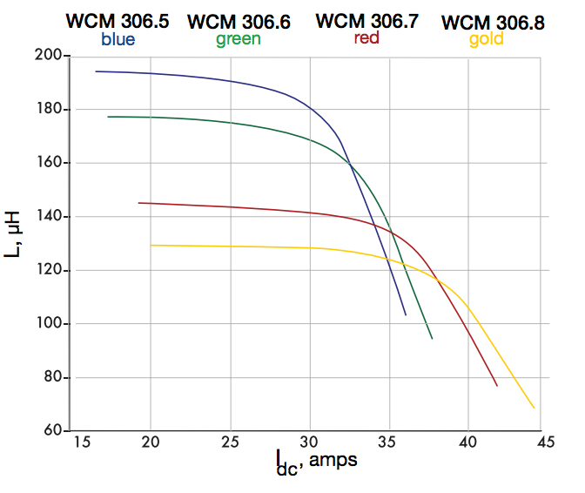

**Figure 3 –** Saturation Current for Inductor WCM 306.8.

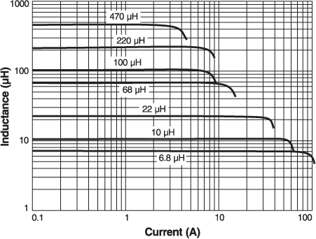

**Figure 4 –** Saturation Current for the Coilcraft Inductors.

There are two major sources of inductor losses: AC-current induced core losses and DC equivalent-resistance heat losses. For each of the selected inductors the core losses are negligible compared to the resistive heating loses, so they are ignored here. The resistive losses may be calculated for both inductors using the maximum RMS current of the charger and the equivalent DC resistance of the inductor:

$$P_{heat}=I_{RMS}^{2}R_{DC}$$

For the Coilcraft inductor:

$$P_{heat}={40}^{2}×0.00295=4.72W$$

For the selected WC Magnetics inductor:

$$P_{heat}={40}^{2}×0.00189=3.02W$$

For the Coilcraft inductor, the manufacturer’s website indicates this would lead to approximately a 45°C increase in inductor temperature. Furthermore, the temperature derating curve (*see figure 4*) indicates that this temperature rise would not be an issue for a wide range of ambient temperatures. WC Magnetics does not publish data on their inductors’ thermal resistance, so there is not a direct method to calculate this part’s temperature rise above ambient; however, it is possible to assume it would remain within normal operating conditions as 40A is far below the part’s rated RMS current.

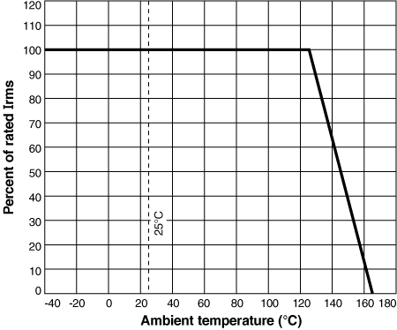

**Figure 4 –** RMS Current Temperature Derating Curve for AGP4233-223ME [3].

**MOSFET Switch Selection**

As discussed in the section on inductor selection, there is a trade-off between switching frequency, inductor requirements, and MOSFET requirements.

For this type of switching converter, the MOSFET is a large source of losses. Losses occur largely in two regions of the switch’s operation: the linear region when the switch is between its “on” and “off” states, and in the saturation region when the switch is “fully on.” Losses in saturation mode are most easily modeled by an equivalent on-state resistance known as the “rds(on).” Losses in the linear mode are more complex to model and much greater than those when the MOSFET is in the saturation region. Therefore it is important to minimize the time that the MOSFET operates in the linear region. This time is dictated by a variety of factors, including gate capacitance, body diode capacitance, and ajlkdfjakd [4]. Additionally the functionality of the MOSFET will depend on its thermal characteristics. Potential MOSFETs for this application are presented in table 4 below.

|  |  |  |  |  |
| --- | --- | --- | --- | --- |
| **Part Number** | **CSD18532KCS** | **IRFH7191** | **IRFH7188** | **IRFH7185** |
| **Manufacturer** | Texas Instruments | International Rectifier | International Rectifier | International Rectifier |
| **Package** | TO-220 | PQFN 5x6 | PQFN 5x6 | PQFN 5x6 |
| **Price ($/1 unit)** | $2.79 | $2.87 | $2.43 | $3.64 |
| **VBRDSS (V)** | 60 | 100 | 100 | 100 |
| **VGS,Max (V)** | 20 | 20 | 20 | 20 |
| **RDS(on) (mOhms)** | **4.2** | **8** | **6** | **5.2** |
| **Qg (nC)** | **44** | **26** | **33** | **36** |
| **Qgd (nC)** | 6.9 | 8.3 | 11 | 11 |
| **Id @ T=25C (A)** | 100 | 80 | 105 | 123 |
| **Ciss (pF)** | 3900 | 1685 | 2116 | 2320 |
| **Coss (pF)** | 470 | 836 | 1074 | 1070 |
| **Qrr - Diode (nC)** | 127 | 126 | 113 | 165 |
| **RΘJC (°C/W)** | 0.6 | 1.2 | 0.95 | 0.8 |
| **RΘJA (°C/W)** | 62 | 35 | 33 | 35 |
| **Q*R** | 185 | 208 | 198 | 187 |

**Table 4 –** Comparison of potential switching MOSFETS with a Q*R figure of merit; unit price collected from Digikey [5][6][7][8].

With modern FET technology, the selection of a MOSFET capable of sustaining 40A continuous in the on-state is trivial. A buck-converter by nature, however, will rarely operate with the switching FET continuously in the on-state. During transitions between the on- and off-states the FET will operate in a linear/triode region in which significantly greater switching losses will occur. Therefore, in order to minimize the total switching losses, it is essential that the MOSFET remain in the linear region of operation for the shortest period of time possible. This transition time is dictated by how quickly the gate-to-source voltage can be transitioned by the driver circuit. In ideal conditions, this is nearly instantaneous. A real-world trade off in the construction of high-current FETs, however, is the presence of a significant capacitance at the gate of the MOSFET, which contains a large charge that must be transferred by the driver circuit. For MOSFETs with a large gate charge this can require pulses of many amperes to switch the MOSFET quickly. If this switching transition is not sufficiently minimized, the converter will incur significant switching losses and the MOSFET will overheat. Typically, there is a tradeoff between minimizing the Rds,ON and the gate charge of a MOSFET. Additionally, some manufacturers produce MOSFETs with low gate charges specifically for high-speed switching applications.

Of the MOSFETs listed in table 4, the IRFH7191 is best suited for this application. All of the MOSFETs have a similar Q*R figure of merit, which indicates the switches performance for both minimizing loss during operation in the saturation region and it ability to be switched between the on and off states quickly so as to minimize time in the linear region of operation [12]. As the RDS(on) values of all the MOSFETs were appropriate for this application, the 7191 was selected for its especially low gate charge and input capacitance; allowing it to perform well during high speed switching.

Power losses in this switch may be estimated by analyzing its performance independently in two operating regions: the linear/triode region during switching; and the saturation region during its on-state [4]. In the on-state the MOSFETs losses may simply be modeled as a series resistance, equal to the value of RDS(on) provided in the datasheet. It is important to note that the value of RDS(on) also varies over temperature, so it is important to account for this in analysis. This characteristic is shown in figure 5 below.

Assuming that the driver circuit ensures MOSFET operation in full saturation (by ensuring VGS is greater than approximately 8V), then at 25°C it is reasonable to assume an RDS(on) of approximately 6.5mΩ, and at 125°C it is reasonable to assume an RDS(on) of 11mΩ. Note that there is a significant increase in switching losses as the FET’s temperature increases. Standard full-load conditions for this charger are specified to be 40A (although lower limits may exist for some inductors due to core saturation). Using these values, the power loss in the FET may be calculated for both temperature conditions:

$$P_{loss}=I_{DS}^{2}R_{DS(on)}$$

For 25°C:

$$P_{loss}=40×6.5=260mW$$

And for 125°C:

$$P_{loss}=40×11=440mW$$

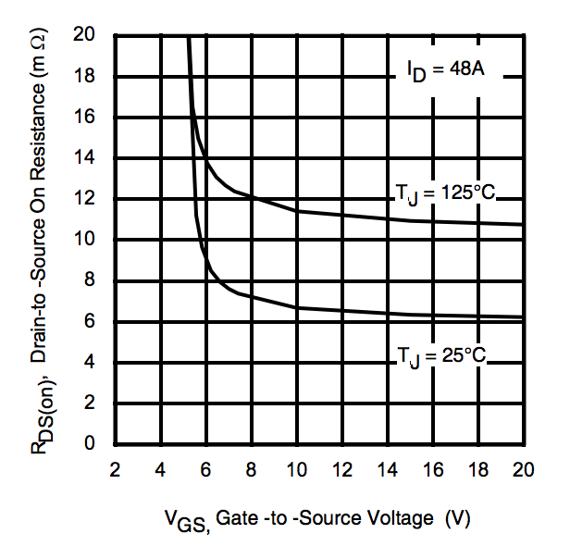

**Figure 5 –** IRFH7191 RDS(on) vs. VGS at 25°C and 125°C.

Analysis of switching losses in the linear region is more complicated, as there are many sources of switching losses [4]. The following sources of switching losses may be calculated with the parameters of the MOSFET which are made available from the manufacturer: turn-off losses, turn-on losses, body diode recovery losses, gate charge losses, and output capacitance losses. These losses are also closely related to the characteristics of the driver circuit; a more powerful driver circuit will reduce the time the MOSFET operates in the linear region.

For the purposes of these analyses, a 2.4A peak driver pull-up current will be assumed, based on typical performances of the LTC4440 high-side high-speed driver IC (see figure 6) [10]. Furthermore, the MOSFET transitions through the linear region as the gate driver removes charge from the MOSFET’s gate. The charge at the gate is related to the MOSFET’s gate to source voltage by the curve shown in figure 7. Note that this is not a purely linear relationship, therefore for turn-on and turn-off losses in the MOSFET, it is useful to analize the MOSFET’s transition in three stages (corresponding to the three linear pieces of the curve in figure 7). Furthermore, the on-state resistance of the MOSFET’s channel is related to the gate-to-source voltage by the curve in figure 8.

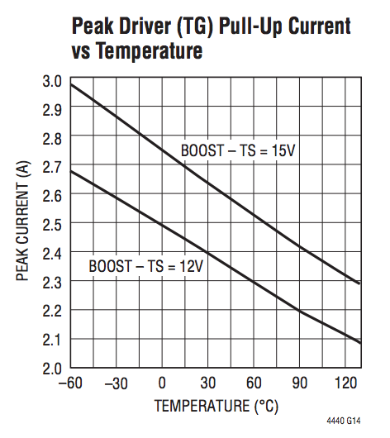

**Figure 6 –** Peak Driver Pull-Up Current for the LTC-4440 High-Side MOSFET Driver.

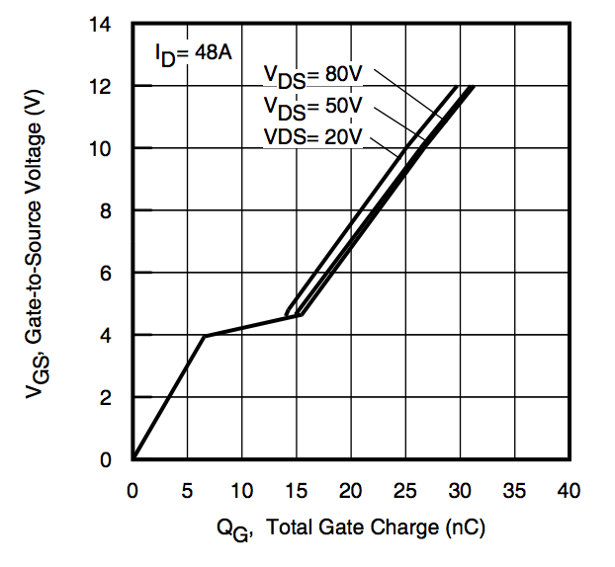

**Figure 7 –** MOSFET Gate-to-Source Voltage vs. Gate Charge; Plateau due to the Miller Effect.

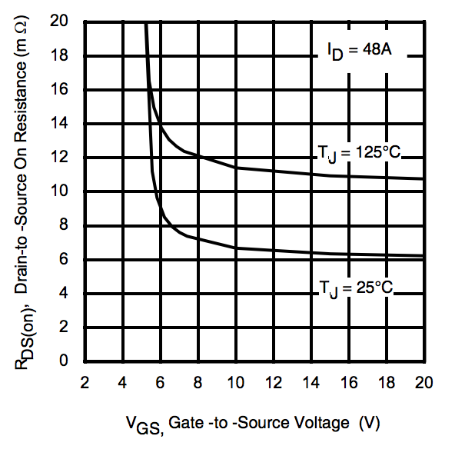

**Figure 8 –** MOSFET On-State Resistance vs. Gate-To-Source Voltage.

Thus with the curves in figures 7 and 8 it is possible to determine the MOSFET’s turn-on and turn-off losses [4]. First is the analysis of the three stages of the MOSFET’s turn-off period.

The first stage consists of the MOSFET’s transition from its high on-state gate-to-source voltage (sustained by the gate driver circuit and the MOSFET’s gate capacitance) to the knee in the curves of figures 7 and 8, which is VGS ≈ 6V. Figure shows that during this transition period RDS(on) remains approximately the same as in the MOSFET’s saturation operation region, therefore the losses here are the same as for the MOSFET’s on-state. This period of the switching is still key; however, as a significant portion of the gate charge is dissipated in this period, leading to the second stage of the turn-off period.

In the second stage of the MOSFET’s

**Rectifier Diode and Synchronous Rectification**

Two approaches are possible for the rectification stage of the power converter, either a high speed switching diode may be used or a MOSFET in synchronous rectification configuration. Using a diode is most straight forward from a converter controller point of view because no additional hardware or software is necessary to control the switching of the diode. This approach has significantly greater power losses; however, as the 0.5V to 1.5V drop across the rectifying diode leads to significant power dissipation in the diode. On the other hand, a MOSFET operating in its saturation has nearly no voltage drop, and thus limited losses. Unfortunately driving two MOSFETs synchronously without crossover is more difficult. Both approaches are explored.

Key characteristics in the selection of a rectifying diode for a buck converter are the ability of the diode to stand up to the voltage and current operating conditions of the power converter and the need to minimize switching losses (by utilizing a diode with a low forward voltage drop, a fast reverse recovery time, and low junction capacitance). Minimizing switching losses is important both for increasing the efficiency of the power converter and in context of selecting a diode which is capable of withstanding the power losses it creates during normal operation. These specifications are summarized in table 5 below.

|  |  |  |
| --- | --- | --- |
| **Parameter** | **Design Specifications** | **Part Specifications** |
| Maximum Reverse Voltage | 48V | 60V |
| Average Rectified Current | 40V | 50V |
| Maximum Forward Voltage Drop | 2.4V | 1.5V |
| Maximum Reverse Recovery Time | 100ns | 20ns |
| Maximum Per-Unit Cost | $10 |  |

**Table 5 –** Rectifying Diode Base Specifications.

The diode component specifications are derived from the characteristics of the power converter. The design specifications are directly related to the converter’s design parameters, while the part specifications included a built in tolerance/factor of safety of approximately 25%. The buck converter’s maximum input voltage dictates the maximum reverse voltage specification. The average rectified current is related to the converter’s maximum output current. The maximum forward voltage drop is derived from the low drop-out voltage of the power converter, which occurs with a 36V input and a 33.6V output. Finally the reverse recovery time is derived from the switching frequency and possible duty cycle values. The 100ns value is derived from the period of a 5% duty cycle at 500kHz. The ability to operate down to a 1% duty cycle would require a maximum reverse recovery time of at most 20ns.

Based on these specifications, the diodes listed in table 6 are potential components for this application. LTSpice simulations were performed on each component to determine each component’s actual suitability for this application.

|  |  |  |  |  |  |  |
| --- | --- | --- | --- | --- | --- | --- |
| **Part** | **Price** | **Maximum Reverse Voltage** | **Average Rectified Current** | **Forward Voltage Drop** | **Reverse Recovery Time** | **Package** |
| VS-60APU02-N3 | $6.71 | 200V | 60A | 1.08V @ 60A | 28ns | TO-247AC |
| APT60S20BG | $5.63 | 200V | 75A | 900mV @ 60A | 55ns | TO-247-2 |

**Table 6 –** Potential Rectifying Diodes.

Unfortunately, SPICE simulations demonstrated that a standard rectifying diode alone would not be appropriate for this application due to significant conduction losses. For this reason a synchronous rectification MOSFET was selected instead. The same MOSFET as the switching MOSFET was used and an analogous MOSFET driver IC was also used: the LTC4444. The LTC4444 is nearly identical to the LTC4440 described previous, except that it drives two N-channel MOSFETs in a synchronous rectification configuration and has built-in shoot-through protection [27]. The performance of this configuration is analyzed in the SPICE Model Simulations section of this report.

**SPICE Model Simulations**

As there is a complex interdependence between switching losses, MOSFET heating, MOSFET gate charge, and MOSFET driver current, a SPICE model of the charger circuitry was created to simulate its electrical and thermal characteristics. The model simulations were run using the LTSpice software [9].

The first simulation model consisted of a buck-converter with models of real-world components, including the LTC4440 MOSFET driver IC. Additionally, MOSFET thermal-analysis was conducted under various circuit loading conditions using MOSFET thermal models provided by the manufacturers. The basic circuit network used for the electrical simulation is show in figure 5, while a basic thermal model is shown in figure 6. It is important to note that the components (such as the MOSFET thermal impedance) in some of these networks are actually macromodels of more complex networks not presented immediately in those figures.

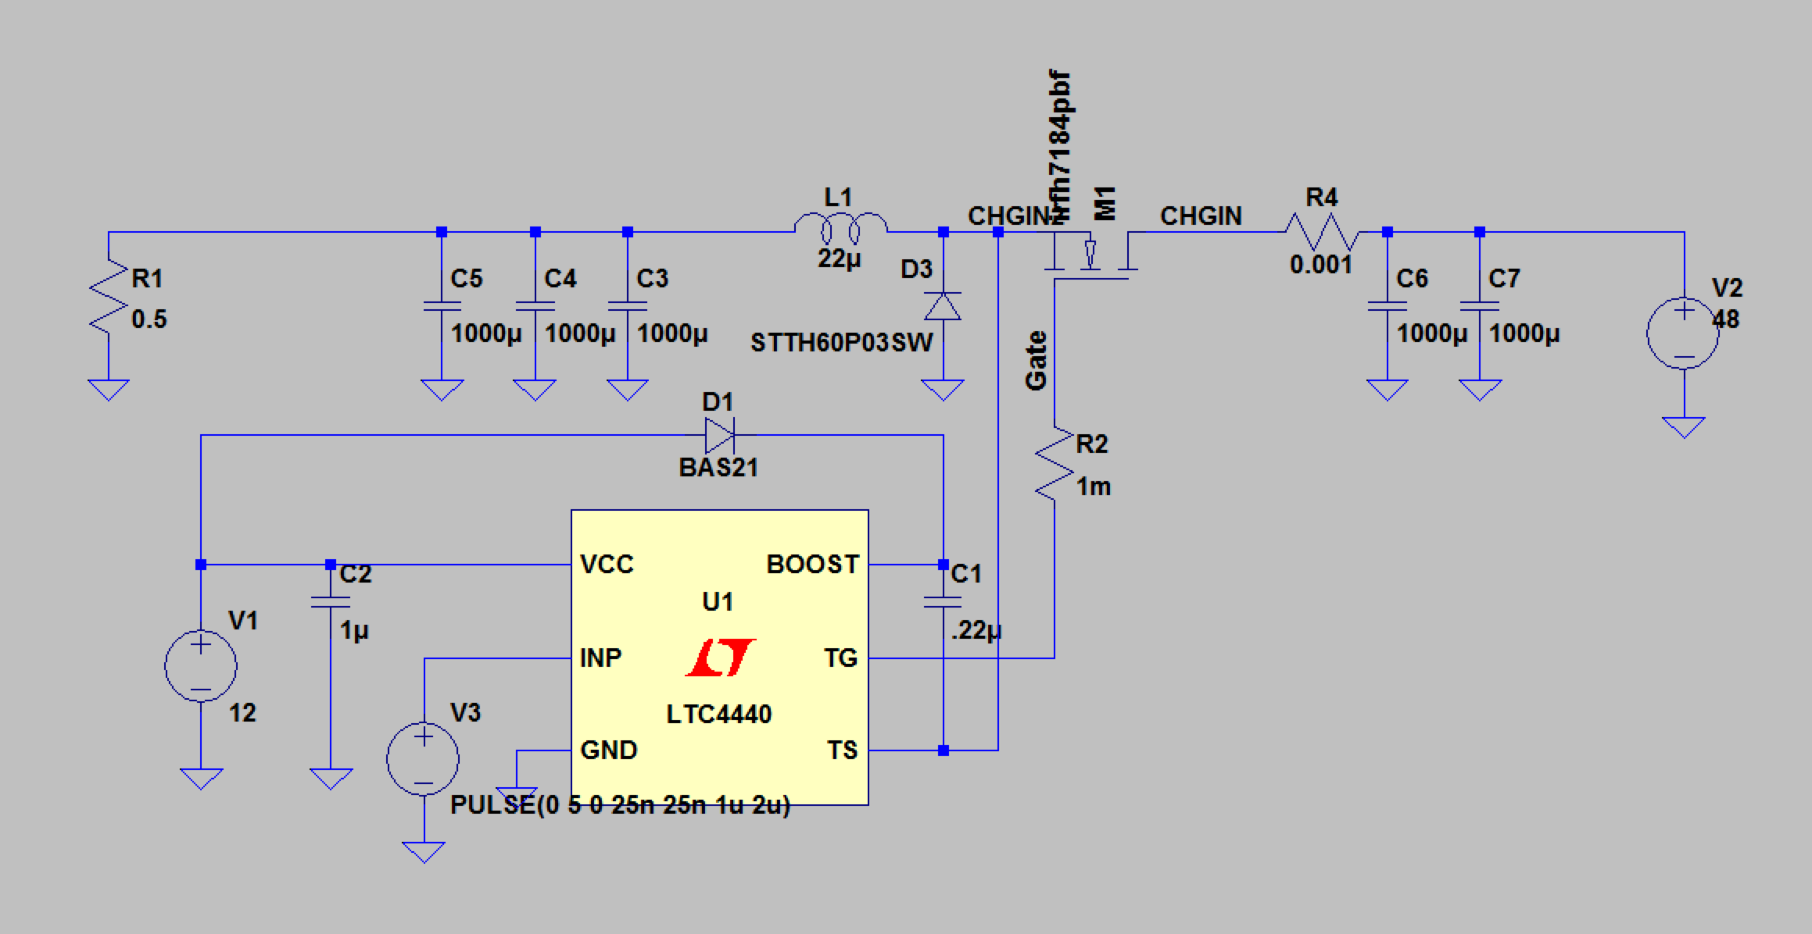

**Figure 5 –** Buck Converter SPICE network in LTSpice.

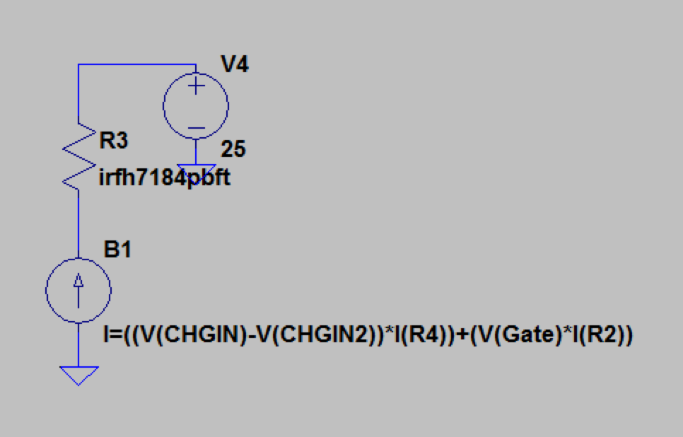

**Figure 6 –** MOSFET Thermal model SPICE network in LTSpice.

The initial model developed was a simple model for conducting baseline tests of various MOSFETs and for verifying model accuracy compared to expected results. Components of the electrical model include the non-ideal inductor L1, ideal filter capacitors with a non-zero ESR, ideal voltage sources for circuit power supply, non-ideal diode models, complex MOSFET models, and a macromodel of the driver IC provided by the manufacturer [10].

The thermal model varied depending on the data provided by the manufacturer. For the International Rectifier MOSFETs, a Foster RC thermal model was used for transient analysis, as the necessary parameters for this model were provided by the manufacturer [6][7][8]. This macromodel was represented by the two-terminal network element R3 (see figure 6). An arbitrary current source (B1) based on the power loss in the MOSFET was used to simulate a heat source, and a DC voltage source (V4) was used to model ambient temperature [11].

The first tests conducted were simple operation of the converter with a resistive load to verify that the simulation’s nets and models were configured properly. A 48V source was used as the input voltage, with a 500kHz driver signal at 50% duty cycle, in order to provide an expected 24V output to a 1.0-Ohm load. The results of the simulation are presented in figure 7 through 9 below.

A basic transient thermal analysis was then performed, producing the results in figures 10 and 11.

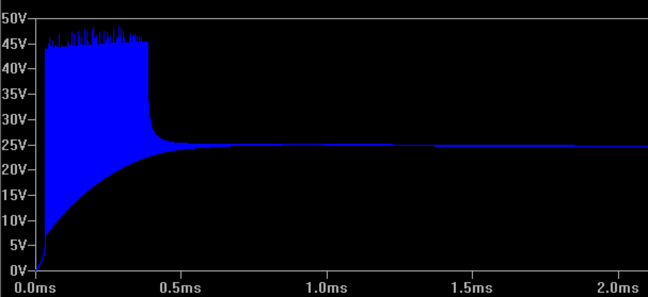

**Figure 7 –** Buck-Converter Output Voltage on Startup (Transient Analysis).

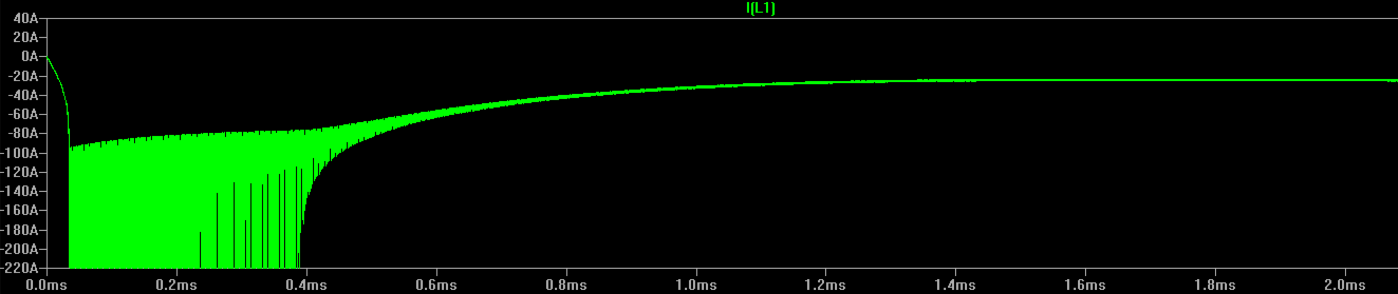

**Figure 8 –** Buck-Converter Inductor Current on Startup (Transient Analysis).

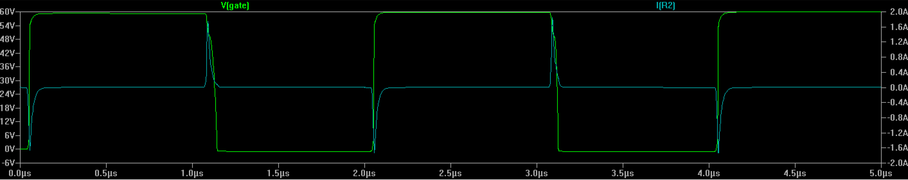

**Figure 9 –** Buck-Converter MOSFET Driver Current (Cyan Trace) and MOSFET Gate Voltage (Green Trace).

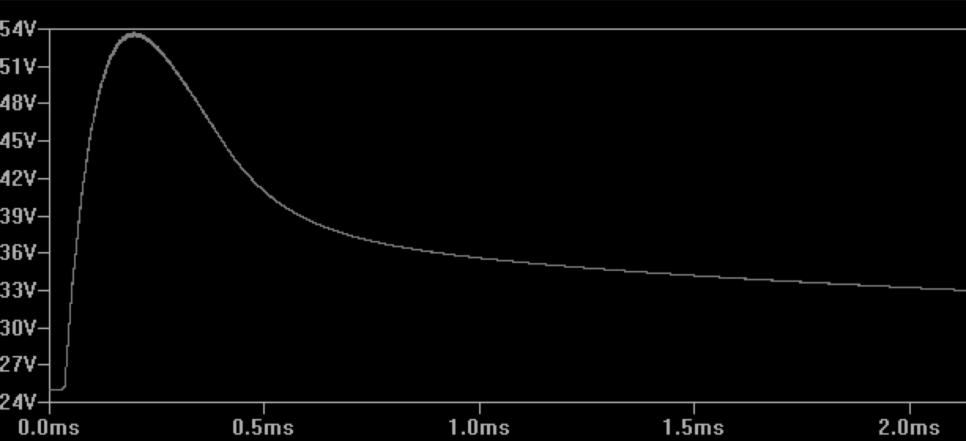

**Figure 10 –** MOSFET Junction Temperature in Degrees Celsius.

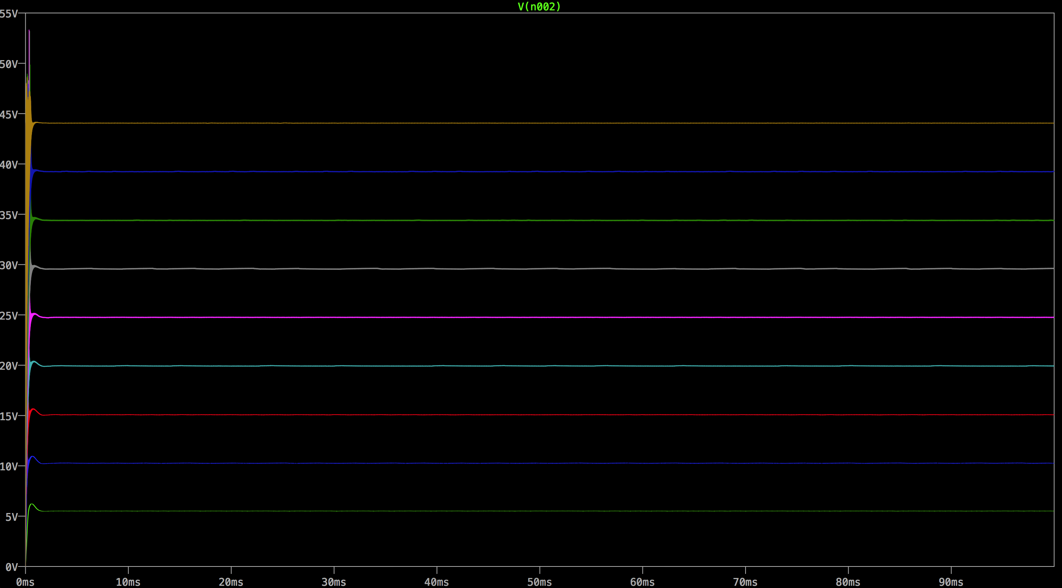

**Figure 11 –** Output Voltage for Various Driver Duty Cycles.

Once this first model had shown initial success, a more advanced model was developed which included synchronous rectification, non-ideal MOSFET models, non-ideal capacitor models, an inductor model with core saturation and equivalent series resistance characteristics, a non-ideal voltage source, and MOSFET RC-ladder network thermal models. The model circuit for this simulation is shown in figure 12 below. External SPICE model files were defined which described the non-ideal components, some of which are including in Appendix B of this report.

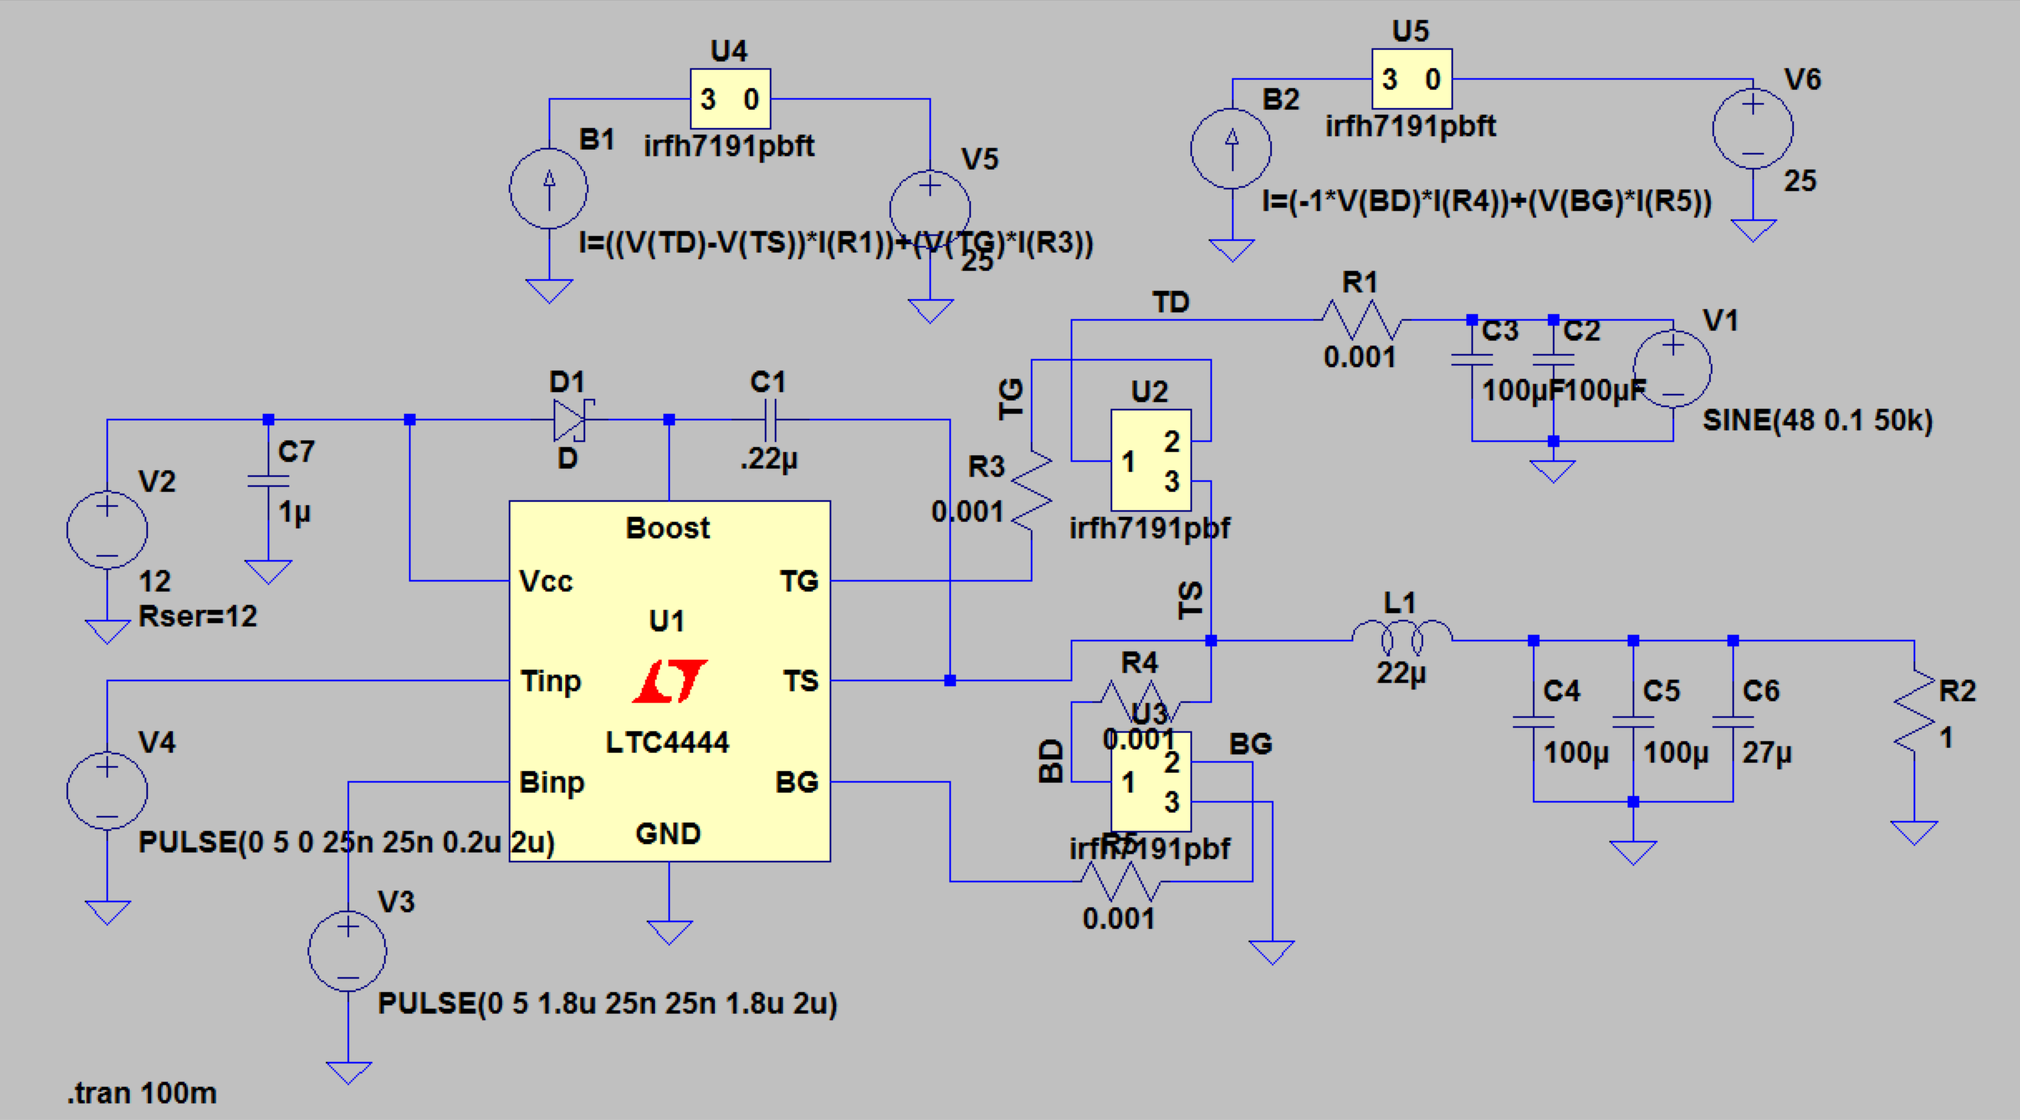

**Figure 12 –** Synchronous Buck Converter Electrical and Thermal Models.

To verify proper performance and ensure that the switching MOSFETs would not overheat under load three transient analysis simulations were performed. In each simulation the converter was provided with a 48VDC source with 10mV ripple and a 1Ohm dummy load. Transient analysis was run for 100ms (typically long enough to show both the system’s transient and steady-state responses). The three simulations were performed for a converter were: test one with a switching duty cyle of 50% (figure 13), test two with a 90% duty cycle (figure 14), and test three with a 10% duty cycle (figure 15).

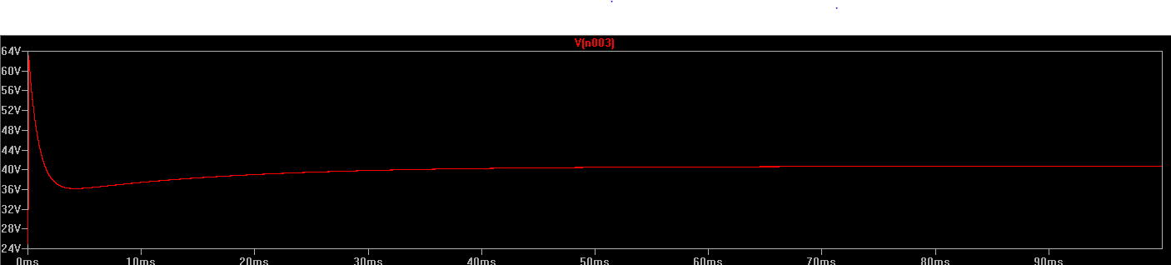

**Figure 13a** **–** Test 1 Top MOSFET Junction Temperature (°C) on Startup.

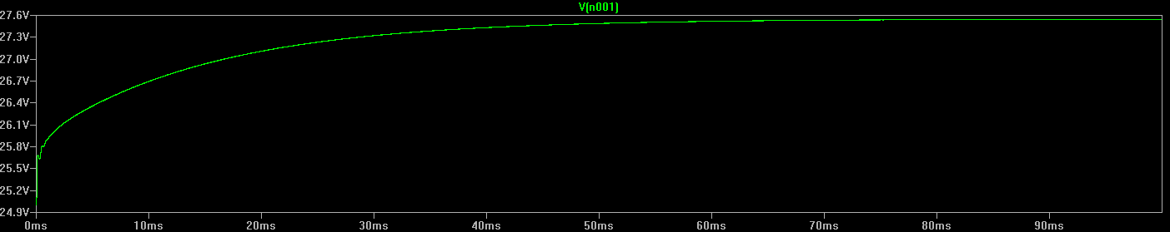

**Figure 13b –** Bottom MOSFET Junction Temperature (°C) on Startup.

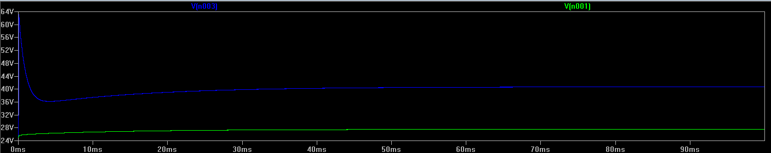

**Figure 13c –** Top and Bottom MOSFET Junction Temperatures (°C) on Startup.

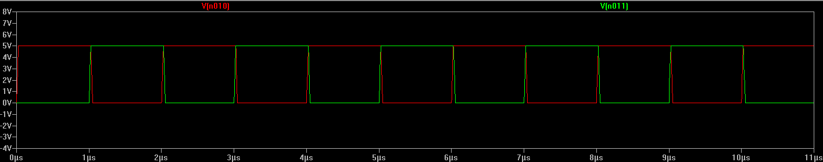

**Figure 13d –** MOSFET Driver PWM Input Signals.

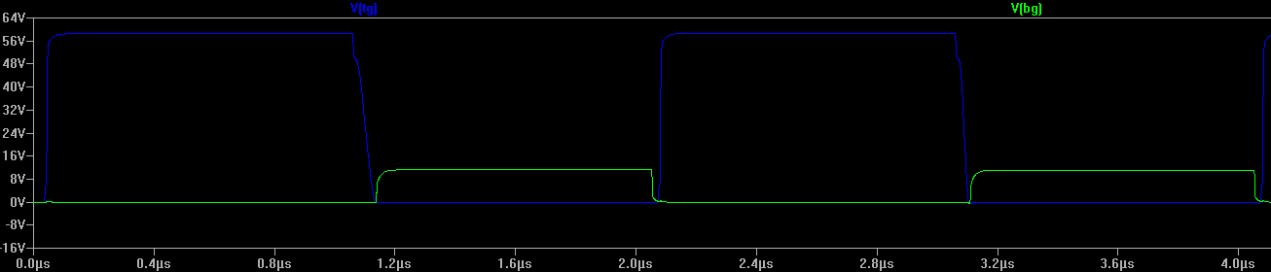

**Figure 13e –** Top and Bottom MOSFET Gate Signals.

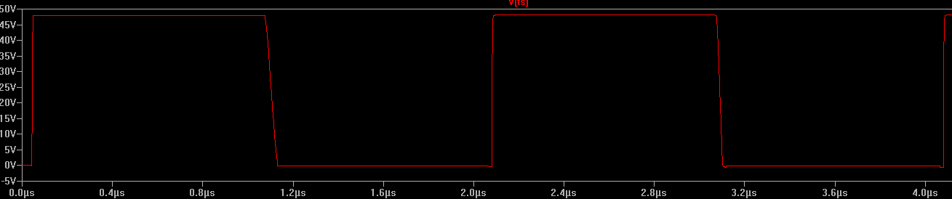

**Figure 13f –** Switching Node Voltage.

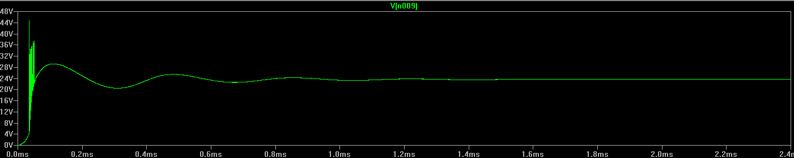

**Figure 13g –** Output Voltage.

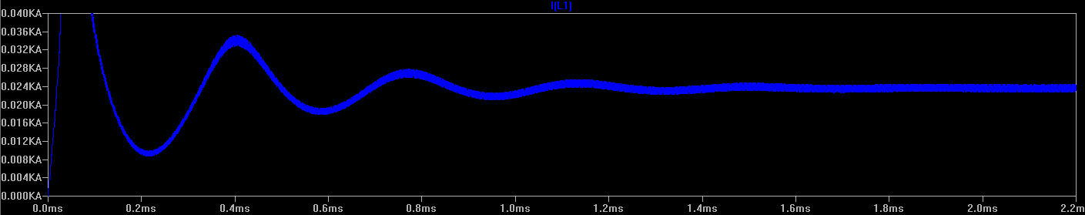

**Figure 13h –** Inductor Current.

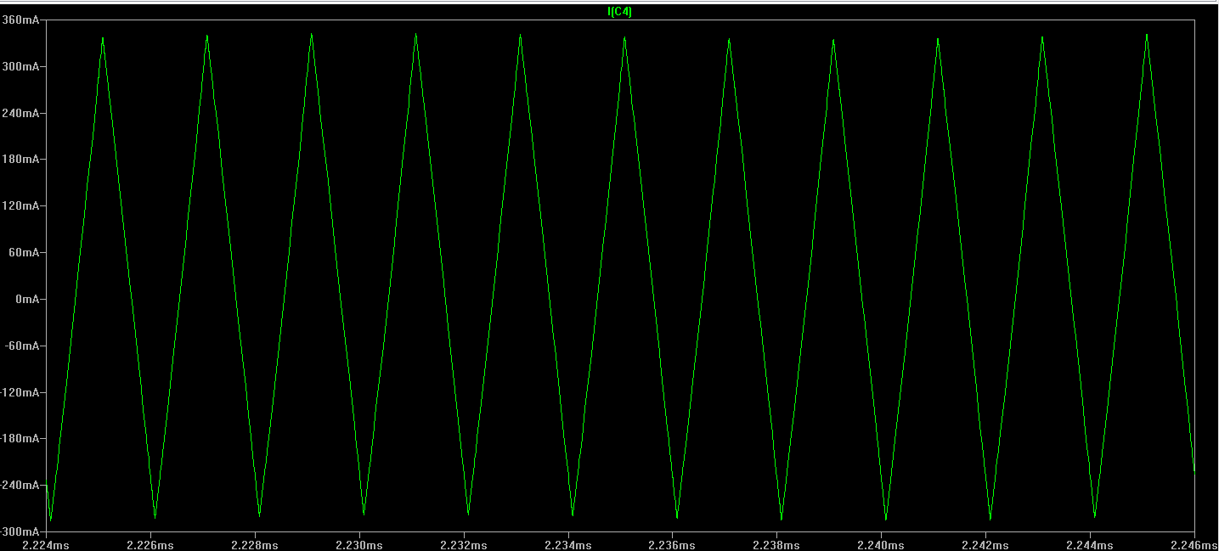

**Figure 13i –** 100uF Capacitor Ripple Current.

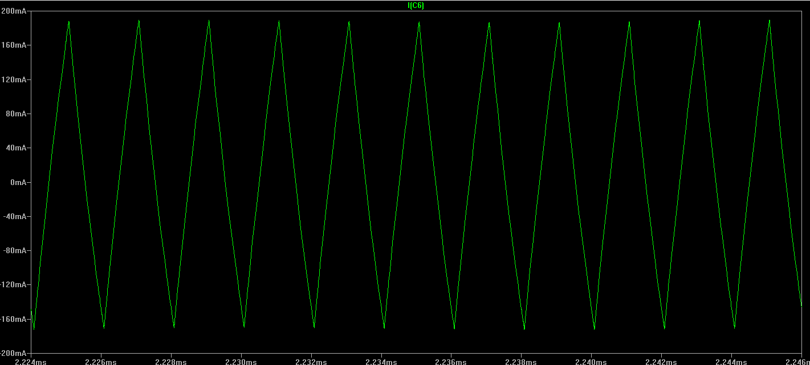

**Figure 13j –** 27uF Output Capacitor Ripple Current.

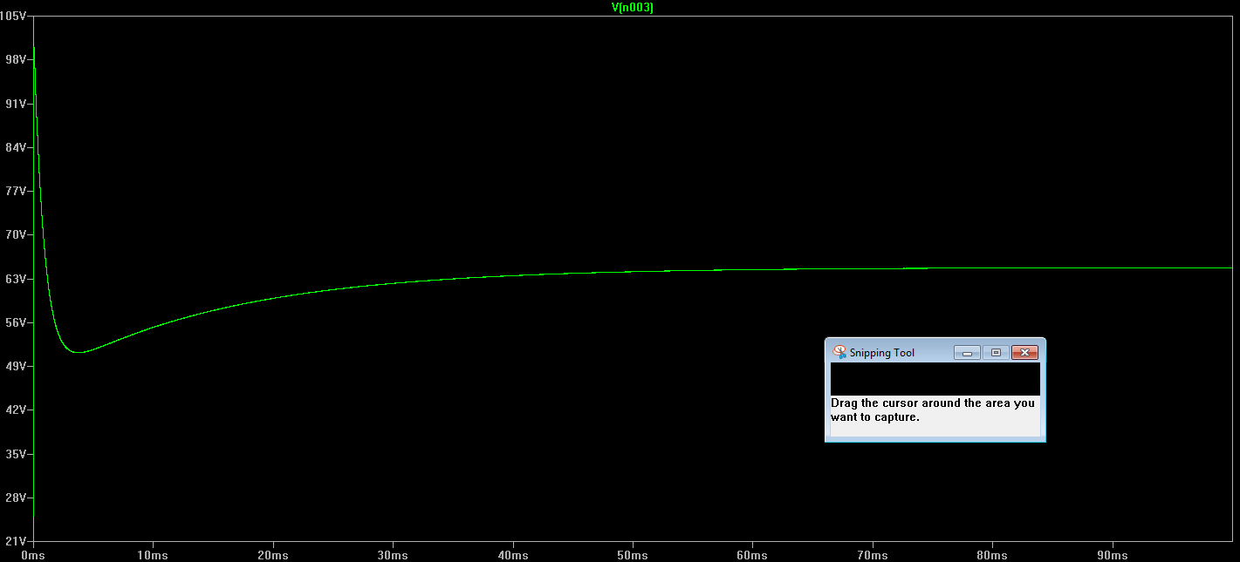

**Figure 14a –** Test 2 Top MOSFET Junction Temperature (°C) on Startup.

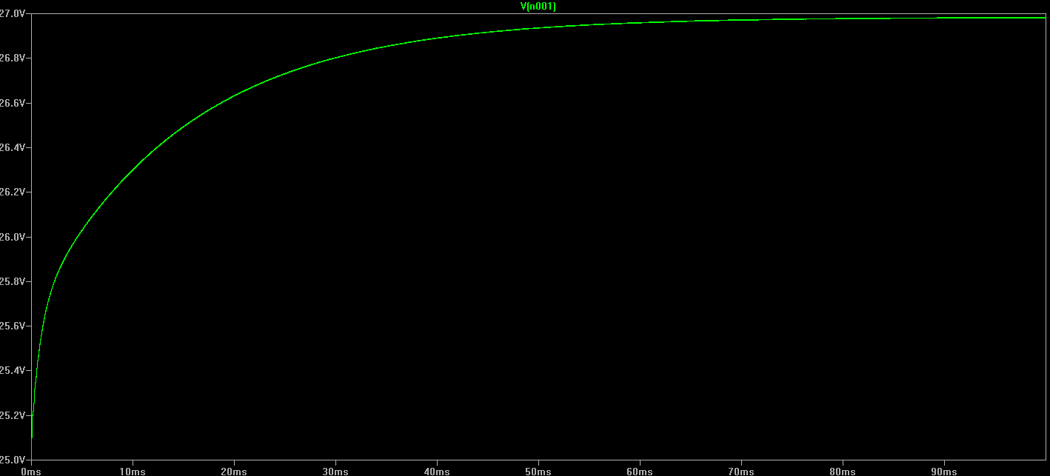

**Figure 14b –** Test 2 Bottom MOSFET Junction Temperature (°C) on Startup.

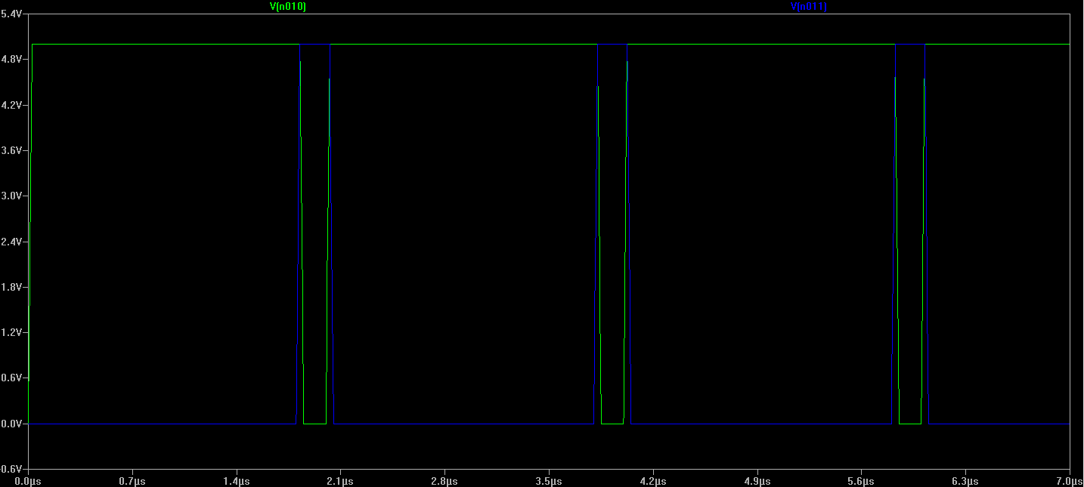

**Figure 14c –** Test 2 MOSFET Driver PWM Input Signal.

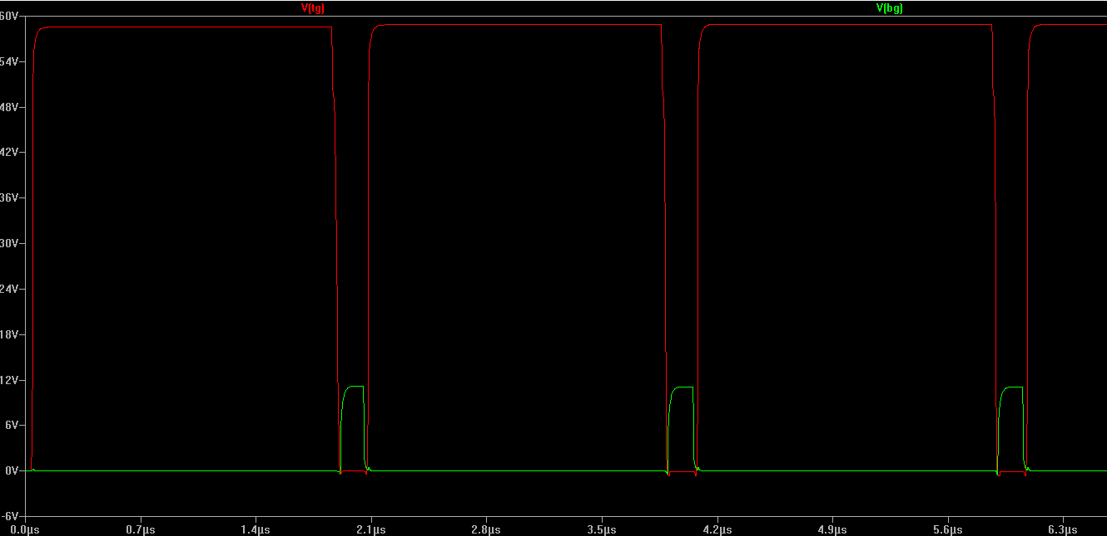

**Figure 14d –** Top and Bottom MOSFET Gate Signals.

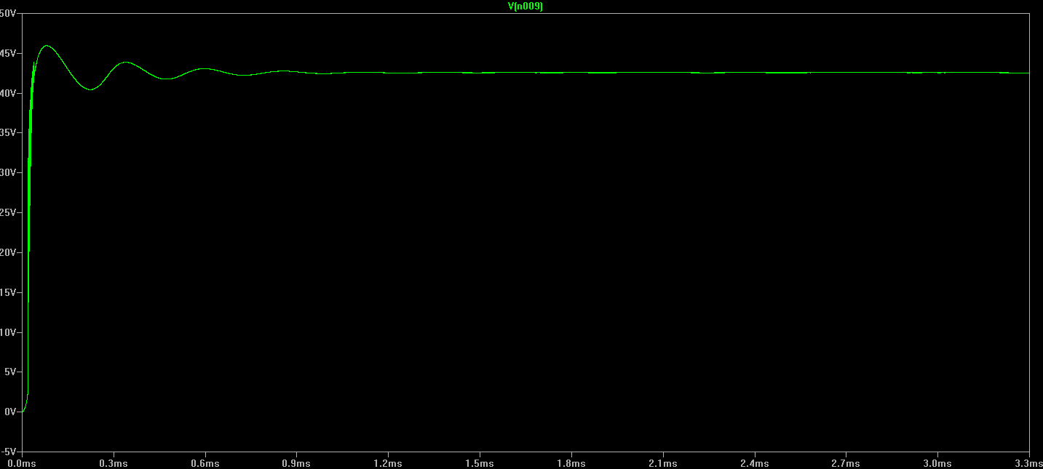

**Figure 14e –** Output Voltage.

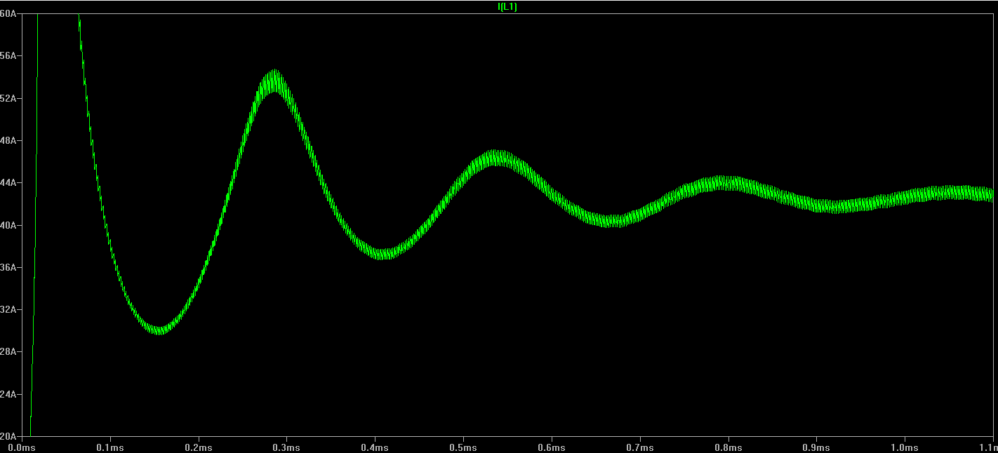

**Figure 14f –** Inductor Current on Startup.

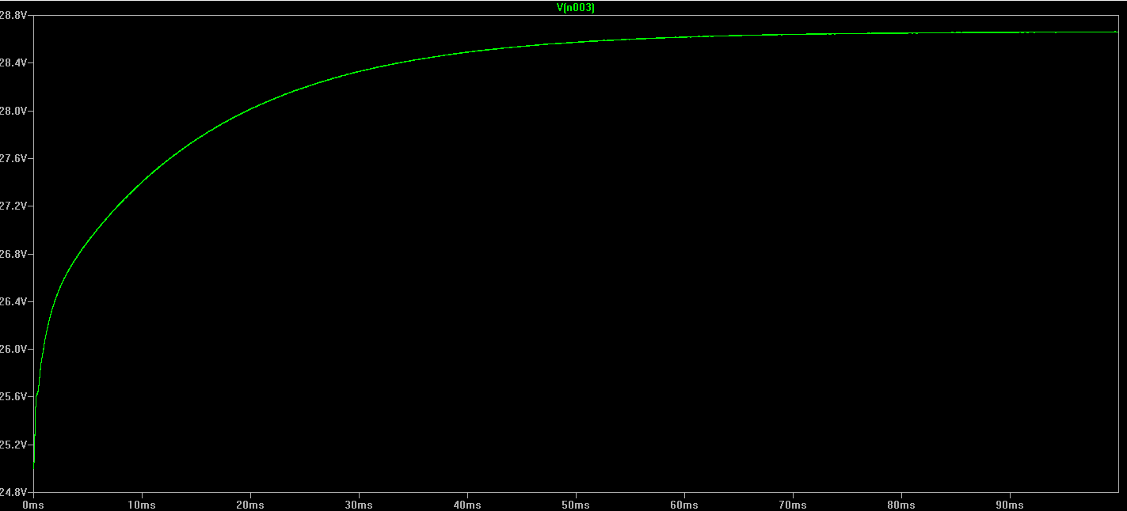

**Figure 15a –** Test 3 Top MOSFET Junction Temperature (°C) on Startup.

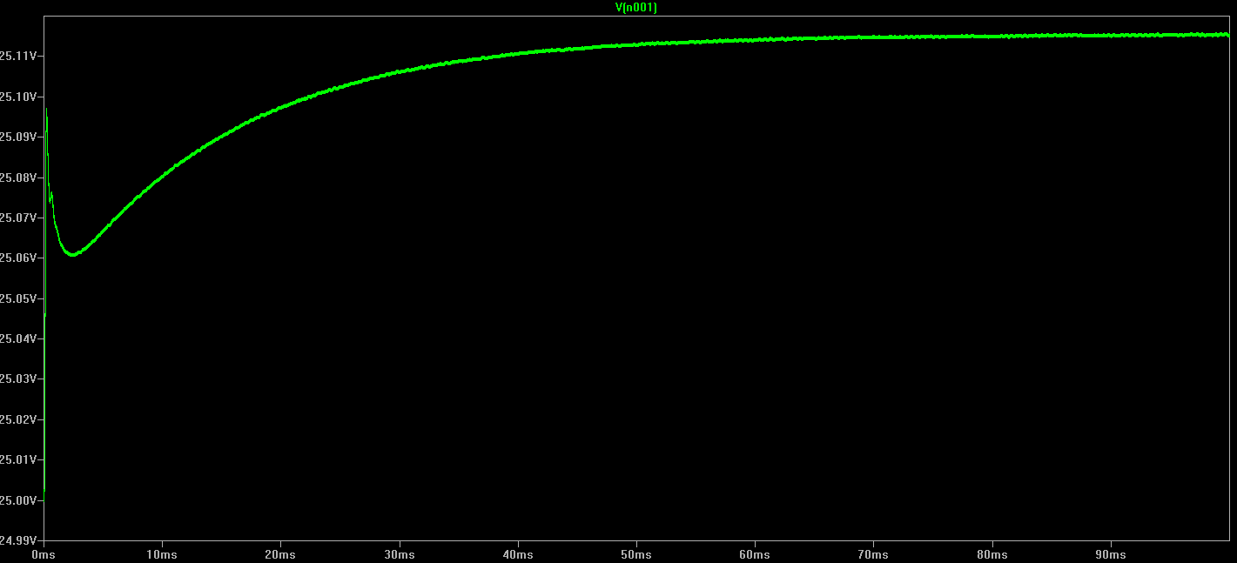

**Figure 15b –** Test 3 Bottom MOSFET Junction Temperature (°C) on Startup.

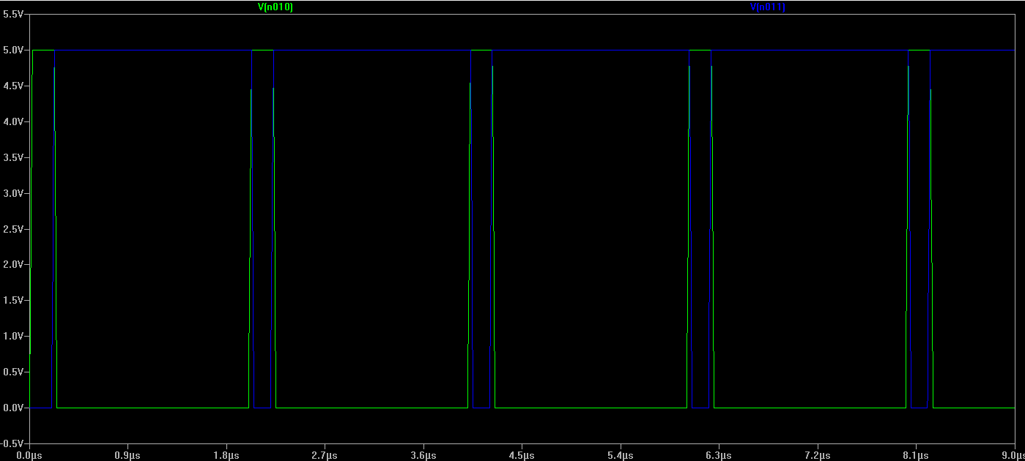

**Figure 15c –** Test 3 MOSFET Driver PWM Input Signals.

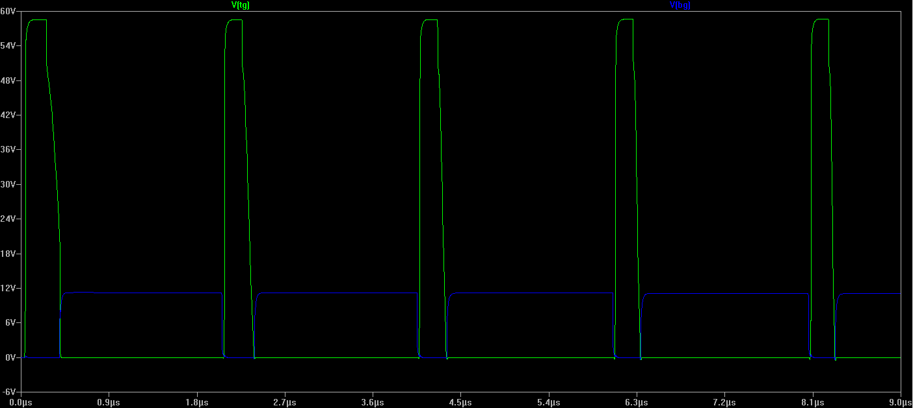

**Figure 15d –** Top and Bottom MOSFET Gate Signals.

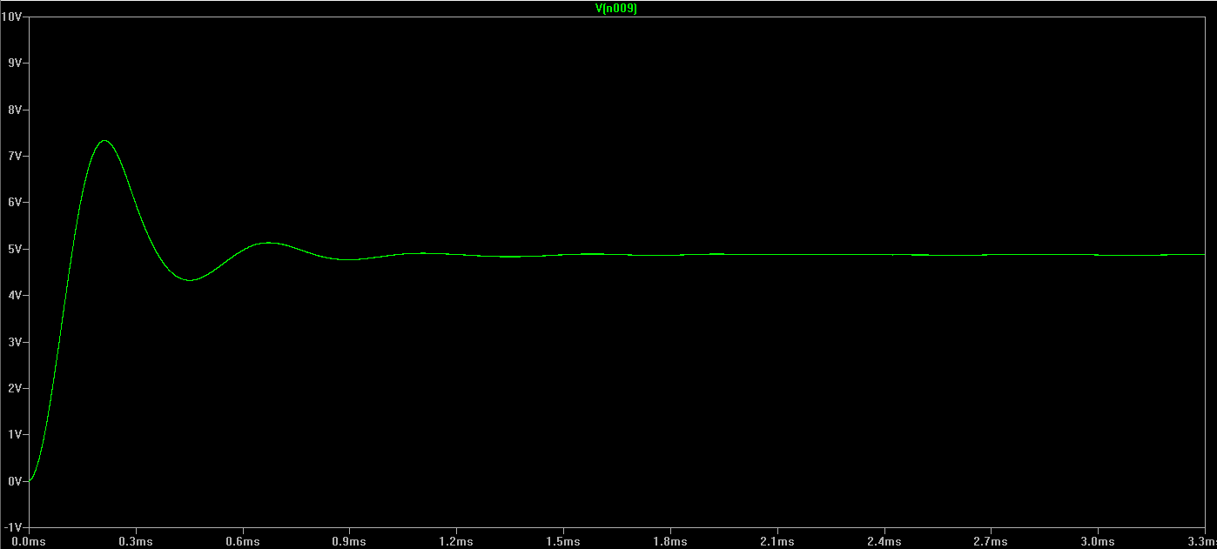

**Figure 15e –** Output Voltage.

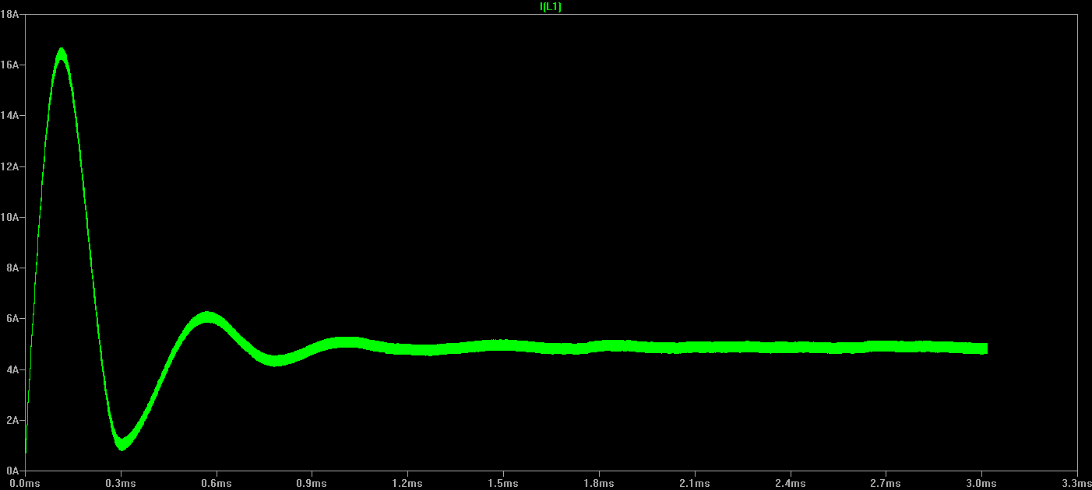

**Figure 15f –** Inductor Current on Startup.

**Acknowledgements**

Thank you to the current and former members of the Mars Rover Design Team for their support and assistance throughout the design process. Specifically, thank you to Lukas Mueller, Jake Armenta, and Sterling Coffey for their contributions to the Power Train Team.

Thank you to Jack Savage for his advice in utilizing LTSpice for modeling thermal equivalent circuits.

Thank you to the various sponsors of Mars Rover Design Team for you donations and advising. Thank you to Coilcraft for providing free magnetics components for this project. Thank you to Battery Bro for providing the team with 200 lithium battery cells at a significantly reduced price.

**References**

1. West Coast Inductors 306 Series Datasheet. <http://wcmagnetics.wpengine.com/wp-content/uploads/2015/02/wcm306.pdf>
2. Coilcraft AGP4233 Series Power Inductor Datasheet. <http://coilcraft.com/pdfs/agp4233.pdf>
3. Coilcraft AGP4233-223ME Temperature Derating Curve. <http://coilcraft.com/misc/agp4233de.html>
4. “Estimating MOSFET Switching Losses Means Higher Performance Buck Converters.” Peter Markowski. EE Times. July 11, 2002. <http://www.eetimes.com/document.asp?doc_id=1225701>
5. Texas Instruments CSD18532KCS Datasheet. <http://www.ti.com/lit/ds/symlink/csd18532kcs.pdf>
6. International Rectifier IRFH7191 Datasheet. <http://www.irf.com/product-info/datasheets/data/irfh7184pbf.pdf>
7. International Rectifier IRFH7188 Datasheet. <http://www.irf.com/product-info/datasheets/data/irfh7188pbf.pdf>
8. International Rectifier IRFH7195 Datasheet. <http://www.irf.com/product-info/datasheets/data/irfh7195pbf.pdf>
9. Linear Technology’s LTSpice Simulation Software. <http://www.linear.com/solutions/ltspice>
10. Linear Technology’s LTC4440 High-Side MOSFET driver. [www.linear.com/product/LTC4440](http://www.linear.com/product/LTC4440)
11. NXP Semiconductors Application Note 11261: Using RC Thermal Models. <http://www.nxp.com/documents/application_note/AN11261.pdf>
12. “Power MOSFET Basics.” Vrej Barkhordarian. International Rectifier. <http://www.irf.com/technical-info/appnotes/mosfet.pdf>
13. LTC6802-2 Multicell Addressable Battery Stack Monitor datasheet. <http://cds.linear.com/docs/en/datasheet/68022fa.pdf>
14. Texas Instruments MSP432P401R Microcontroller. <http://www.ti.com/product/MSP432P401R>
15. Texas Instruments MSP432P401R Launchpad Development Board. <http://www.ti.com/tool/MSP-EXP432P401R>
16. International Rectifier IRLS3034 Power MOSFET datasheet. <http://www.irf.com/product-info/datasheets/data/irls3034-7ppbf.pdf>
17. Horowitz, Paul, and Windfield Hill. *The Art of Electronics*. 3rd ed. New York: Cambridge UP, 2015. Print.
18. Linear Technology’s LT1910 Protected High Side MOSFET Driver. <http://www.linear.com/product/LT1910>
19. Woodbank Communications Ltd. *Lithium Battery Failures*. <http://www.mpoweruk.com/lithium_failures.htm>
20. Hyoungkwon, Kim. *Product Specification: Rechargeable Lithium Ion Battery Model: 18650HE4 2500mAh*. LG Chem. <https://cdn.shopify.com/s/files/1/0674/3651/files/LG18650_HE4.PDF?828>
21. Andrea, Davide. *Battery Management Systems for Large Lithium-Ion Packs*. Artech House, 2010. Print.
22. Alegro MicroSystems ACS770 Current Sensor Datasheet. <http://www.allegromicro.com/~/media/Files/Datasheets/ACS770-Datasheet.pdf>
23. Texas Instruments TLC6C5912-Q1 Power Logic 12-Channel Shift Register LED Driver. <http://www.ti.com/lit/ds/symlink/tlc6c5912-q1.pdf>
24. Kingbright DC7G3HWA 10 Segment Bar Graph Array. <http://www.kingbrightusa.com/images/catalog/SPEC/DC7G3HWA.pdf>
25. Hart, Daniel W. *Power Electronics*. New York: McGraw-Hill, 2011. Print.
26. GNU Octave. <https://www.gnu.org/software/octave/>
27. Linear Technology’s LTC4444 High Voltage Synchronous N-Channel MOSFET Driver. <http://www.linear.com/product/LTC4444>

**Appendix A: Inductor Calculations Octave Source Code**

clc; close all; clear all;

% Case 1A: 36V input, Current Mode Control, 40A output

Vs = 36; % Source Voltage

Vo = [20:0.1:33.6]; %Output voltage

Io = 40; % Output Current

f = [50000:5000:500000]; % Switching Frequency

Lmin = zeros(columns(Vo),columns(f));

for i = 1:columns(Vo)

for j = 1:columns(f)

Lmin(i,j) = ((1-(Vo(1,i)/Vs))*(Vo(1,i)/Io))/(2*f(1,j));

endfor

endfor

length(Vo)

length(f)

surf(f,Vo,Lmin)

xlabel("Switching Frequency (Hz)", "fontsize", 14);

ylabel("Output Voltage (V)", "fontsize" , 14);

zlabel("Inductance (H)", "fontsize", 14);

title("Inductance as a Function of Output Voltage and Switching Frequency \n for Current Mode Control with 36V Input", "fontsize", 14);

figure();

%----------------------------------------------------------

% Case 1B: 48V input, Current Mode Control, 40A output

Vs = 36; % Source Voltage

Vo = [20:0.1:33.6]; %Output voltage

Io = 40; % Output Current

f = [50000:5000:500000]; % Switching Frequency

Lmin = zeros(columns(Vo),columns(f));

for i = 1:columns(Vo)

for j = 1:columns(f)

Lmin(i,j) = ((1-(Vo(1,i)/Vs))*(Vo(1,i)/Io))/(2*f(1,j));

endfor

endfor

length(Vo)

length(f)

surf(f,Vo,Lmin)

xlabel("Switching Frequency (Hz)", "fontsize", 14);

ylabel("Output Voltage (V)", "fontsize" , 14);

zlabel("Inductance (H)", "fontsize", 14);

title("Inductance as a Function of Output Voltage and Switching Frequency \n for Current Mode Control with 48V Input", "fontsize", 14);

figure();

%----------------------------------------------------------

% Case 2A: 36V Input, Voltage Mode Control, 33.6V Output

Vs = 36; % Source Voltage

Vo = 33.6; %Output voltage

Io = [0.5:0.1:40]; % Output Current

f = [50000:5000:500000]; % Switching Frequency

Lmin = zeros(columns(Io),columns(f));

for i = 1:columns(Io)

for j = 1:columns(f)

Lmin(i,j) = ((1-(Vo/Vs))*(Vo/Io(1,i)))/(2*f(1,j));

endfor

endfor

length(Io)

length(f)

surf(f,Io,Lmin)

xlabel("Switching Frequency (Hz)", "fontsize", 14);

ylabel("Output Current (A)", "fontsize" , 14);

zlabel("Inductance (H)", "fontsize", 14);

title("Inductance as a Function of Output Current and Switching Frequency \n for Voltage Mode Control with 36V Input", "fontsize", 14);

figure();

%----------------------------------------------------------

% Case 2B: 48V Input, Voltage Mode Control, 33.6V Output

Vs = 48; % Source Voltage

Vo = 33.6; %Output voltage

Io = [0.5:0.1:40]; % Output Current

f = [50000:5000:500000]; % Switching Frequency

Lmin = zeros(columns(Io),columns(f));

for i = 1:columns(Io)

for j = 1:columns(f)

Lmin(i,j) = ((1-(Vo/Vs))*(Vo/Io(1,i)))/(2*f(1,j));

endfor

endfor

length(Io)

length(f)

surf(f,Io,Lmin)

xlabel("Switching Frequency (Hz)", "fontsize", 14);

ylabel("Output Current (A)", "fontsize" , 14);

zlabel("Inductance (H)", "fontsize", 14);

title("Inductance as a Function of Output Current and Switching Frequency \n for Voltage Mode Control with 48V Input", "fontsize", 14);

**Appendix B: SPICE Component Models**

SPICE electrical and thermal models for switching MOSFET based on model provided by International Rectifier:

.SUBCKT irfh7191pbf 1 2 3

* SPICE3 MODEL WITH THERMAL RC NETWORK

**************************************

* Model Generated by MODPEX *

*Copyright(c) Symmetry Design Systems*

* All Rights Reserved *

* UNPUBLISHED LICENSED SOFTWARE *

* Contains Proprietary Information *

* Which is The Property of *

* SYMMETRY OR ITS LICENSORS *

*Commercial Use or Resale Restricted *

* by Symmetry License Agreement *

**************************************

* Model generated on Jun 22, 15

* MODEL FORMAT: SPICE3

* Symmetry POWER MOS Model (Version 1.0)

* External Node Designations

* Node 1 -> Drain

* Node 2 -> Gate

* Node 3 -> Source

M1 9 7 8 8 MM L=100u W=100u

.MODEL MM NMOS LEVEL=1 IS=1e-32

+VTO=3.22757 LAMBDA=0.0387698 KP=40.7929

+CGSO=1.66908e-05 CGDO=1e-11

RS 8 3 0.00387432

D1 3 1 MD

.MODEL MD D IS=2.97314e-11 RS=0.00118245 N=1.12709 BV=100

+IBV=0.00025 EG=1.2 XTI=1 TT=1e-07

+CJO=3.55718e-09 VJ=5 M=0.699721 FC=0.5

RDS 3 1 3e+08

RD 9 1 0.0001

RG 2 7 3.43205

D2 4 5 MD1

* Default values used in MD1:

* RS=0 EG=1.11 XTI=3.0 TT=0

* BV=infinite IBV=1mA

.MODEL MD1 D IS=1e-32 N=50

+CJO=6.86137e-10 VJ=1.0949 M=0.9 FC=1e-08

D3 0 5 MD2

* Default values used in MD2:

* EG=1.11 XTI=3.0 TT=0 CJO=0

* BV=infinite IBV=1mA

.MODEL MD2 D IS=1e-10 N=0.629462 RS=3e-06

RL 5 10 1

FI2 7 9 VFI2 -1

VFI2 4 0 0

EV16 10 0 9 7 1

CAP 11 10 6.86137e-10

FI1 7 9 VFI1 -1

VFI1 11 6 0

RCAP 6 10 1

D4 0 6 MD3

* Default values used in MD3:

* EG=1.11 XTI=3.0 TT=0 CJO=0

* RS=0 BV=infinite IBV=1mA

.MODEL MD3 D IS=1e-10 N=0.629462

.ENDS irfh7191pbf

*SPICE Thermal Model Subcircuit

.SUBCKT irfh7191pbft 3 0

R_RTHERM1 3 2 0.3875

R_RTHERM2 2 1 0.0022

R_RTHERM3 1 0 0.7996

C_CTHERM1 3 2 0.0023

C_CTHERM2 2 1 3.5901

C_CTHERM3 1 0 0.0189

.ENDS irfh7191pbft

**Appendix C: Bill of Materials**

|  |  |  |  |  |  |  |
| --- | --- | --- | --- | --- | --- | --- |
| **Component** | **Description** | **Supplier** | **Part Number** | **Unit Price** | **Qty** | **Total Price** |
| **Capacitors** | | | | | | |
| C1206C104K5RAC7867 | 0.1 uF, 1206 | Digikey | 399-1249-1-ND | $0.04 | 10 | $2.39 |
| C1206C224K5RACTU | 0.22 uF, 1206 | Digikey | 399-1251-1-ND | $0.13 | 1 | $1.30 |
| CC1206KRX7R9BB103 | 10 nF, 1206 | Digikey | 311-1174-1-ND | $0.09 | 2 | $1.38 |
| GMK316F106ZL-T | 10 uF, 1206 | Digikey | 587-1352-1-ND | $0.19 | 1 | $1.90 |
| C3216X7R1H105K160AB | 1 uF, 1206 | Digikey | 445-1423-1-ND | $0.17 | 4 | $4.13 |
| EEH-ZA1V470P | 47 uF, 1206 | Digikey | P15454CT-ND | $1.91 | 4 | $30.56 |
| **Resistors** | | | | | | |
| RC1206FR-07100RL | 100 Ohm, Thick film, 1206 | Digikey | 311-100FRCT-ND | $0.02 | 9 | $1.16 |
| RC1206FR-07100KL | 100 kOhms, Thick film, 1206 | Digikey | 311-100KFRCT-ND | $0.03 | 1 | $0.32 |
| PAC300001009FAC000 | 10 Ohms, 3W, 1%, through hole | Digikey | PPC3D10.0CT-ND | $0.65 | 8 | $20.72 |
| RC1206FR-0710KL | 10 kOhm, 1%, 1206 | Digikey | 311-10.0KFRCT-ND | $0.02 | 8 | $1.16 |
| RC1206FR-07120RL | 120 Ohm, 1206 | Digikey | 311-120FRCT-ND | $0.03 | 2 | $0.32 |
| 311-1.00MFRCT-ND | 1 Mohm, 1206 | Digikey | RC1206FR-071ML | $0.03 | 3 | $0.64 |
| 311-1.00KFRCT-ND | 1 kOhm, 1206 | Digikey | RC1206FR-071KL | $0.02 | 3 | $0.58 |
| 311-200FRCT-ND | 200 Ohms, 1206 | Digikey | RC1206FR-07200RL | $0.01 | 20 | $1.30 |
| 311-3.30KFRCT-ND | 3.3 kOhms, 1206 | Digikey | RC1206FR-073K3L | $0.02 | 8 | $1.16 |
| 311-470ERCT-ND | 450 Ohms, 1206 | Digikey | RC1206JR-07470RL | $0.02 | 8 | $0.88 |
| 311-4.7KERCT-ND | 5 kOhms, 1206 | Digikey | RC1206JR-074K7L | $0.02 | 1 | $0.24 |
| 311-60.4KFRCT-ND | 60 kOhms, 1206 | Digikey | RC1206FR-0760K4L | $0.03 | 2 | $0.32 |
|  | Trim Pot |  |  |  | 1 | $0.00 |
|  | PTC, 1206, board power supply fuse |  |  |  | 1 | $0.00 |
| **Inductors** | | | | | | |
| AGP4233-223ME | Charger Buck Converter Power Inductor | |  |  | 1 | $0.00 |
| BLM31PG330SN1L | BMS front-end power source input filter | Digikey | 490-5989-1-ND | $0.31 | 1 | $1.24 |
| Fair-Rite 2773019447 | Board power supply DC-DC converters output filter | Newark | 93B9533 | $0.37 | 2 | $3.69 |
| **Semiconductors/ICs** | | | | | | |
| IRLS3034-7P | High current SMD MOSFET, pack on/off swtich, D2PAK-7 | Digikey | IRLS3034-7PPBF-ND | $6.45 | 2 | $51.60 |
| LTST-C150KFKT | LED 1206 | Digikey | 160-1403-1-ND | $0.24 | 9 | $8.78 |
| DMG3420U-7DICT-ND | Small N-Channel MOSFET (Buzzers and Fans) | Digikey | DMG3420U-7 | $0.28 | 6 | $6.72 |
| ACS770 | Current Sensor IC | Digikey | 620-1538-5-ND | $8.07 | 2 | $48.42 |
| BAS21 | Small diode, IC driver | Digikey | BAS21-FDICT-ND | $0.13 | 1 | $1.04 |
| BAT46W | Zener Diode (BMS Zener Diode) | Digikey | 568-6017-1-ND | $0.28 | 2 | $2.80 |
| IRFH7191TRPBF | Charger Switching MOSFET | Digikey | IRFH7191TRPBFCT-ND | $1.86 | 1 | $18.64 |
| D-STTH60P03SW | Charger Switching Diode | Digikey |  |  | 1 | $0.00 |
| LED-DC7G3HWA | 10 Segment LED Bar Graph | Digikey | 754-1671-5-ND | $1.96 | 1 | $7.84 |
| LT1910 | MOSFET High-Side Driver IC for Pack on/off switch | Digikey | LT1910ES8#PBF-ND | $4.15 | 1 | $16.60 |
| LT6004 | OpAmp for temperature sensor analog reference voltage buffer | Digikey | LT6004CMS8#PBF-ND | $2.21 | 1 | $6.63 |
| LTC4440 | MOSFET Driver for charger switch | Digikey | LTC4440EMS8E#PBF-ND | $3.52 | 1 | $17.60 |
| MAX3077 | RS-485 line driver | Digikey | MAX3077EESA+-ND | $3.57 | 1 | $28.56 |
| MMSZ5267B | Zener Diode (BMS Zener Diode) | Digikey | MMSZ5267BT1GOSCT-ND | $0.19 | 1 | $1.92 |
| SI2309CDS-T1-E3 | P-Channel MOSFET - Cell Balancing | Digikey | SI2309CDS-T1-E3CT-ND | $0.46 | 8 | $14.85 |
| MSP432P401R | TI Launchpad Microcontroller |  |  |  | 1 | $0.00 |
| PDZ7.5B | Cell input zener diode | Digikey | 568-6456-1-ND | $0.31 | 8 | $9.79 |
| LTC6803-2 | BMS Analog Front-End IC | Digikey | LTC6803IG-2#PBF-ND | $17.00 | 1 | $68.00 |
| OKI-78SR12 | 12V DC-DC Converter |  |  |  | 1 | $0.00 |
| OKI-78SR5 | 5V DC-DC Converter | Digikey | 811-2196-5-ND | 4.26 | 1 | $21.30 |
| TLC6C5912 | High power, 12bit shift register IC | Digikey | 296-40591-1-ND | $1.75 | 1 | $7.00 |
| **Electromechanical** | | | | | | |
|  | 1x16, 0.1" header pins for LCD Screen | |  |  | 1 | $0.00 |
| 25136NAH | SPDT Switch - Power Supply Switch | Newark | 96C6560 | $5.30 | 1 | $21.20 |
| 22-23-2021 | 1x2, 0.1" Latching header pins for temperature sensors | Digikey | WM4200-ND | $0.15 | 2 | $4.59 |
| 22-23-2031 | 1x3, 0.1" Latching header pins for cooling fans | Digikey | WM4201-ND | $0.22 | 4 | $3.44 |
| 22-23-2091 | 1x9, 0.1" Latching header pins for cell voltage taps | Digikey | WM4207-ND | $0.55 | 2 | $5.51 |
| 22013027 | 1x2 Crimp housing | Digikey | WM2000-ND | $0.13 | 2 | $0.78 |
| 22013097 | 1x9 Crimp housing | Digikey | WM2007-ND | $0.42 | 2 | $2.52 |
| 8550101 | Crimp pins | Digikey | WM2312CT-ND | $0.14 |  | $11.41 |
|  | SMD Buzzer |  |  |  | 2 | $0.00 |
| JST B6B-XH | Connector of charger power supply communication | Digikey | 455-2271-ND | $0.26 | 1 | $1.04 |
| XHP-6 | JST crimp housing | Digikey | 455-2218-ND | $0.14 | 2 | $0.70 |
| SXH-001T-P0.6 | JST crimp pins | Digikey | 455-1135-1-ND | $0.04 | 12 | $1.88 |
| 399700102 | Charger power input connector | Digikey | WM3193-ND | $6.84 | 1 | $41.04 |
| 1020 | 1x10 Female headers for LED bargraph mounting | Pololu | 1020 | $0.62 | 2 | $6.20 |
|  | RJ-45 Jack |  |  |  | 1 | $0.00 |
| COM-12992 | SWITCH-MOMENTARY-2SMD - Momentary switch, bar graph on/off | Sparkfun | COM-12992 | $0.50 | 1 | $2.00 |